Traumatic Brain Injury (TBI)
Instruments User Manual



Version 4.0
June 2012

Department of Veterans Affairs
Office of Information and Technology (OIT)
Product Development

Revision History
Date | Version | Description | Author
5/14/2012 | 4.0 | Increment 4 Final, approved manual | J. Sanders  S. Smith  D. Zaudtke
5/10/2012 | 3.5 | Final Review | S. Smith
5/9/2012 | 3.4 | Incorporated instrument business logic and sample CPRS reports. | D. Zaudtke
5/7/2012 | 3.3 | Peer Review of Section 3.3 | S. Smith
5/2/2012 | 3.2 | Incorporated Peer review comments | D. Zaudtke
5/1/2012 | 3.1 | Peer Review | S. Smith
4/25/2012 | 3.0 | Incorporated major revisions, updated for increment 4, added Preface section, Glossary, expanded TBI Follow Up Section | D. Zaudtke
9/06/2011 | 1.2 | Incorporated minor revisions, edited screenshots | D. Zaudtke
5/06/2011 | 1.1 | Incorporated Comments from Business Owner | J. Sanders; T. Delgado
1/21/2011 | 1.0 | Final Version | T. Delgado; L. Berry
1/20/2011 | 0.4 | Incorporate Comments | V. Dunie
1/19/2011 | 0.3 | Peer Review | L. Berry
1/15/2011 | 0.2 | Editorial Review | V. Dunie
1/15/2011 | 0.1 | Draft Version | V. Dunie

Table of Contents
1. Preface 1
1.1. Typographical Conventions Used in the Manual 1
1.2. Command Buttons and Command Icons 1
2. Background 2
2.1. Related Documents 2
3. Software Details 3
3.1. Starting the Application 3
3.2. Select Instrument Screen 3
3.2.1. Comprehensive TBI Evaluation 10
3.2.2. TBI Follow-Up Assessment Screen 27
3.2.3. Mayo-Portland Adaptability Inventory (MPAI) 38
3.2.4. Rehabilitation and Reintegration Plan 44
3.3. Sample Report 49
A. Business Rules 50
A.1. Comprehensive TBI Evaluation Business Rules 50
A.2. TBI Follow-up Evaluation Instrument Business Rules 55
B. Glossary 57
C. Web Based Application Elements 62

Table of Tables
Table 1 – Typographical Conventions 1
Table 2 – Graphical Conventions 1
Table 3 – Comprehensive TBI Evaluation Business Rules 50
Table 4 – TBI Evaluation Instrument Business Rules 55

Table of Figures
Figure 1 – Patient Confirm Screen 3
Figure 2 – Select Instrument 4
Figure 3 – Instrument Associations 5
Figure 4 – Select Note Drop-Down Box 6
Figure 5 – Link to Consult 7
Figure 6 – Instrument Associations > Link to Encounter 8
Figure 7 – Select Hospital Admission 8
Figure 8 – Current Stay 9
Figure 9 – Unscheduled or New Visit 9
Figure 10 – Comprehensive TBI Evaluation Part 1 10
Figure 11 – Comprehensive TBI Evaluation Part 2 11
Figure 12 – Comprehensive TBI Evaluation Part 3 12
Figure 13 – Comprehensive TBI Evaluation Part 4 13
Figure 14 – Comprehensive TBI Evaluation Part 5 14
Figure 15 – Comprehensive TBI Evaluation Part 6 15
Figure 16 – Comprehensive TBI Evaluation Part 7 16
Figure 17 – Comprehensive TBI Evaluation Part 8 17
Figure 18 – Comprehensive TBI Evaluation Part 9 18
Figure 19 – Comprehensive TBI Evaluation Part 10 19
Figure 20 – Comprehensive TBI Evaluation Part 11 20
Figure 21 – Comprehensive TBI Evaluation Part 12 21
Figure 22 – Comprehensive TBI Evaluation Part 13 22
Figure 23 – Comprehensive TBI Evaluation Part 14 23
Figure 24 – Comprehensive TBI Evaluation Part 15 24
Figure 25 – Comprehensive TBI Evaluation Part 16 25
Figure 26 – TBI Follow-Up Assessment Screen Part 1 27
Figure 27 – TBI Follow-Up Assessment Screen Part 2 28
Figure 28 – TBI Follow-Up Assessment Screen Part 3 29
Figure 29 – TBI Follow-Up Assessment Screen Part 4 30
Figure 30 – TBI Follow-Up Assessment Screen Part 5 31
Figure 31 – TBI Follow-Up Assessment Screen Part 6 32
Figure 32 – TBI Follow-Up Assessment Screen Part 7 33
Figure 33 – TBI Follow-Up Assessment Screen Part 8 34
Figure 34– TBI Follow-Up Assessment Screen Part 9 35
Figure 35 – TBI Follow-Up Assessment Screen Part 10 36
Figure 36 – Mayo Portland Adaptability Inventory Part 1 39
Figure 37 – Mayo Portland Adaptability Inventory Part 2 40
Figure 38 – Mayo Portland Adaptability Inventory Part 3 41
Figure 39 – Mayo Portland Adaptability Inventory Part 4 42
Figure 40 – Rehabilitation and Reintegration Plan Part 1 45
Figure 41 – Rehabilitation and Reintegration Plan Part 2 46
Figure 42 – Rehabilitation and Reintegration Plan Part 3 47
Figure 43 – Rehabilitation and Reintegration Plan Part 4 48
Figure 44 – Sample Report 49
Figure 45 – Tool Tip for Text Box 63

Preface

Typographical Conventions Used in the Manual
Throughout this document, the following fonts and other conventions are used:
Table 1 – Typographical Conventions
Font | Used for… | Examples:
Blue text, underlined | Hyperlink to another document or URL | ftp.fo-slc.med.va.gov
Green text, dotted underlining | Hyperlink within this document | See Release History for details.
Courier New | Patch names, VistA filenames | Patch names will be in this font
Franklin Gothic Demi | Keyboard keys  Web application panel, pane, tab, and button names | < F1 >, < Alt >, < L >  Other Registries panel  [Delete] button
Microsoft Sans Serif | Software Application names | Traumatic Brain Injury (TBI)
Microsoft Sans Serif bold | Registry names | TBI
Microsoft Sans Serif bold | Database field names | Mode field
Microsoft Sans Serif bold | Report names | National Summary Report
Microsoft Sans Serif bold | Organization and Agency Names | DoD, VA
Microsoft Sans Serif, 50% gray and italics | Read-only fields | Procedures
Times New Roman | Normal text | Information of particular interest
Times New Roman Italic | Text emphasis | “It is very important . . .”
Times New Roman Italic | National and International Standard names | International Statistical Classification of Diseases and Related Health Problems
Times New Roman Italic | Document names | Traumatic Brain Injury (TBI) Registry User Manual

Table 2 – Graphical Conventions
Graphic | Used for…
 | Information of particular interest regarding the current subject matter.
 | A tip or additional information that may be helpful to the user.
 | A warning concerning the current subject matter.
 | Information about the history of a function or operation; provided for reference only.
 | Indicates an action or process which is optional
 | Indicates a resource available either in this document or elsewhere

Command Buttons and Command Icons
A command button initiates an action. It is a rectangular “3-dimensional” shape with a label that specifies what action will be performed when the button is clicked.
Common examples are shown at left. Command buttons that end with three dots indicate that selecting the command may evoke a subsidiary window.
In some cases, a command icon performs the same function, but appears on the menu bar and has a plain, flat appearance. One example is shown at left.
In the text of this document, both command button and command icon names appear inside square brackets. Examples: [Search], [Save].

Background
The Veterans Health Administration (VHA) is charged with supporting the Presidential Task Force on Returning Global War on Terror Heroes. The Task Force has stated in the Global War on Terror (GWOT) report (recommendation P-7) that the Department of Veterans Affairs (VA) shall “create a ‘Traumatic Brain Injury’ Surveillance Center and Registry to monitor returning service members who have possibly sustained head injury and thus may potentially have a traumatic brain injury in order to provide early medical intervention.”
The Traumatic Brain Injury (TBI) Registry software applications collect data on the population of Veterans who participated in Operation Enduring Freedom/Operation Iraqi Freedom (OEF/OIF). These individuals need to be seen within 30 days for a comprehensive evaluation. Each facility can produce local reports (information related to patients evaluated and treated in their system).
The TBI Instruments are a set of comprehensive evaluation questionnaires (initial and follow up) designed to provide rehabilitation professionals with a vehicle by which they can assess patients and collect patient information. The information collected from these instruments is electronically transferred and stored in the form of a medical progress note in the patient’s electronic record. This progress note can be retrieved through the Computerized Patient Record System (CPRS).
The set of TBI Instruments include the Comprehensive TBI Evaluation, TBI Follow-Up Assessment, The Mayo-Portland Adaptability Inventory (MPAI), and the Rehabilitation and Reintegration Plan.

Related Documents
These related documents are available at http://www.va.gov/vdl/application.asp?appid=198

Software Details

Starting the Application
To start TBI Instruments, follow these steps:
- Log into CPRS

- On the tool bar, select Tools > TBI Instruments.
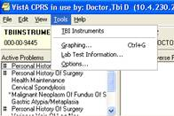

Note: TBI Instruments is equipped with a time-out security feature. If you receive any warning message, close the browser and repeat this process to log in.

- The TBI Instruments Patient Confirm page opens. This confirms the patient name and SSN match in the TBI Registry.
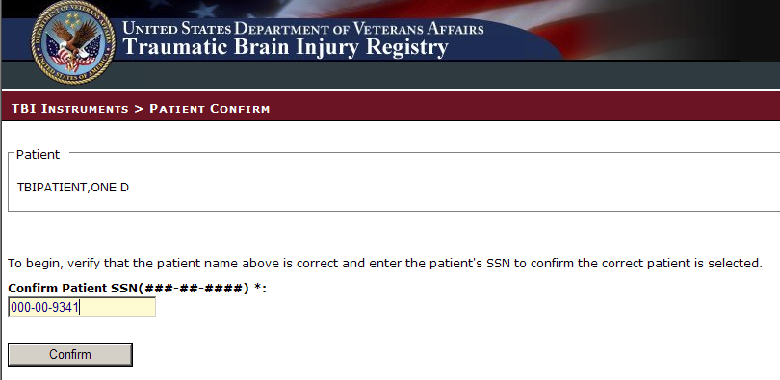
Figure 1 – Patient Confirm Screen

Select Instrument Screen
The TBI Instruments > Confirm Patient and Select Instrument screen displays. Confirm the patient name and SSN match in the TBI Registry.
Select the appropriate Instrument you want to administer from the list by clicking the [Select] button.
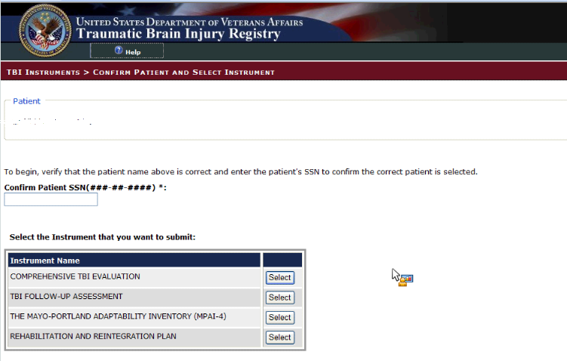
Figure 2 – Select Instrument
The TBI Instruments > Instrument Associations screen displays. The patient name and the Instrument Type previously selected are presented on the screen.
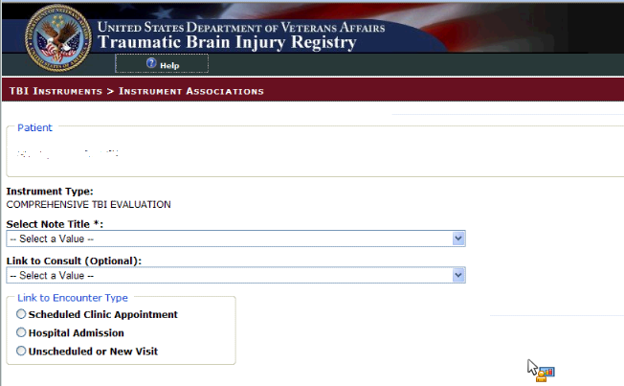
Figure 3 – Instrument Associations
Select an appropriate Note Title from the Select Note Title drop-down list. Appropriate Note Titles for TBI patients begin with TBI. This selection is required.
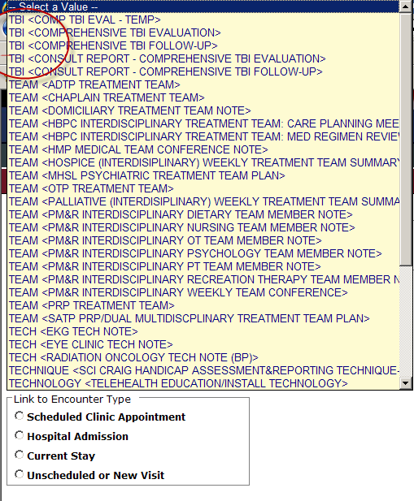
Figure 4 – Select Note Drop-Down Box
If the note title selected is classified as a ‘Consult Report’, the user entry will complete a consult in CPRS. Use the Link to Consult drop-down list to select the appropriate consult to which the entry should be linked in CPRS. While this selection is optional, the user must make a selection from the list in order for the consult report to be linked to a consult in CPRS.
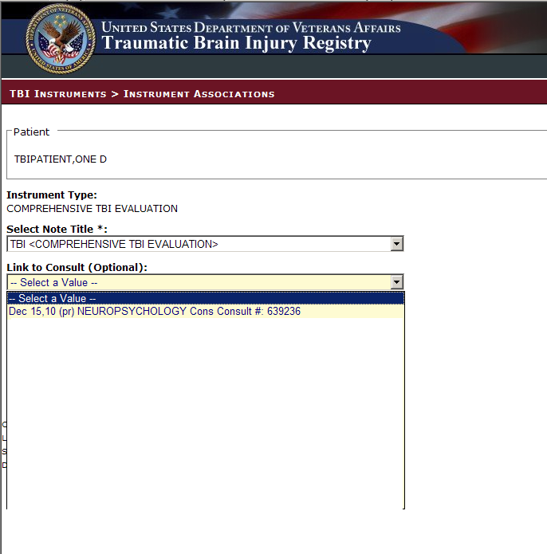
Figure 5 – Link to Consult
The Link to Consult drop-down list is populated with previously ordered consults for this patient. If the user selects a consult from the drop-down list, the data then entered via the selected TBI Instrument will be associated with the selected consult.
Use the radio button to select the appropriate Link to Encounter Type from the list.
If you select Scheduled Clinic Appointment, the application searches the period of time one month before today through one month after today. If any appointments are found, they are loaded into the Select the Scheduled Clinic Appointment drop down list. Select an appointment to proceed to the next step. If the user wishes to expand the date range for the search, the user can input new start and end dates and click Get Appointments and then proceed to the next step. This step associates the current instrument with the selected appointment.
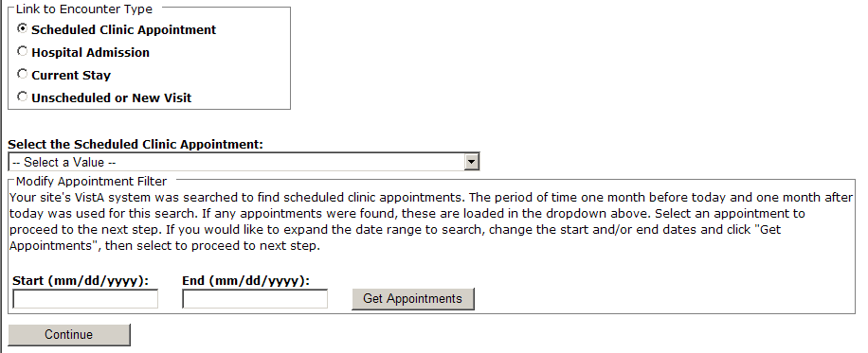
Figure 6 – Instrument Associations > Link to Encounter
If you select Hospital Admission, the application searches for previous hospital stays. If any are found, they are loaded into the Select the Hospital Admission drop down list, and the user can make the appropriate selection. If no previous stays are found for the patient, the user must select a different encounter type from the Link to Encounter Type list in order to proceed.
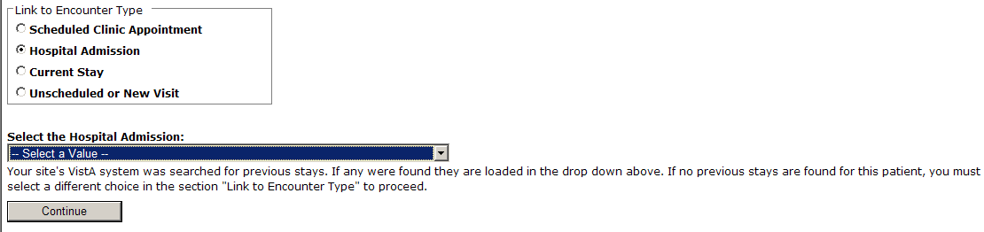
Figure 7 – Select Hospital Admission
If you select Current Stay, the next action required is to click [Continue] to move to the next screen.
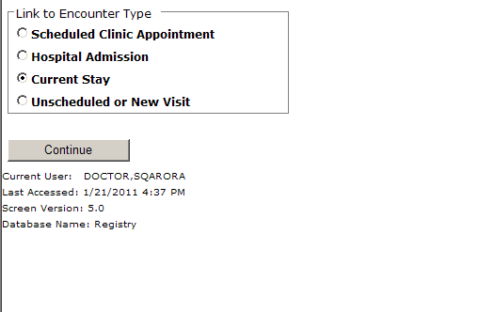
Figure 8 – Current Stay
If you select Unscheduled or New Visit, the application searches to find all locations at your site which begin with TBI. If any locations are found, they are loaded into the Location drop down list. If the user wants to search using a different location, the user can change the default search string and click [Get Locations]. After selecting a location, the user can click [Continue] to move to the next screen.
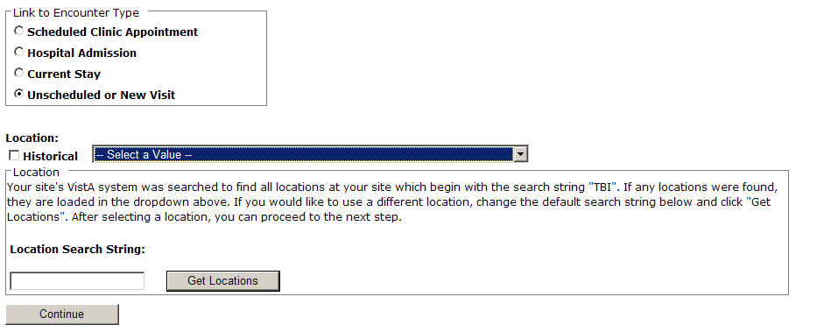
Figure 9 – Unscheduled or New Visit

Comprehensive TBI Evaluation
The TBI Instruments > Comprehensive TBI Evaluation screen displays.
Select the appropriate answer for each patient.
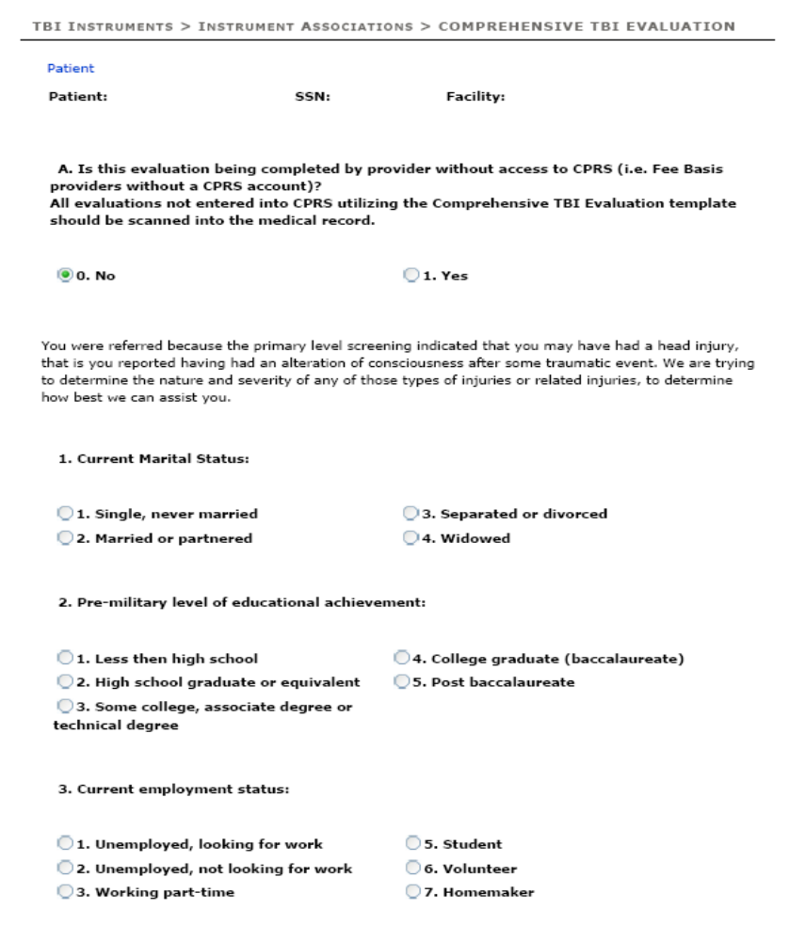
Figure 10 – Comprehensive TBI Evaluation Part 1

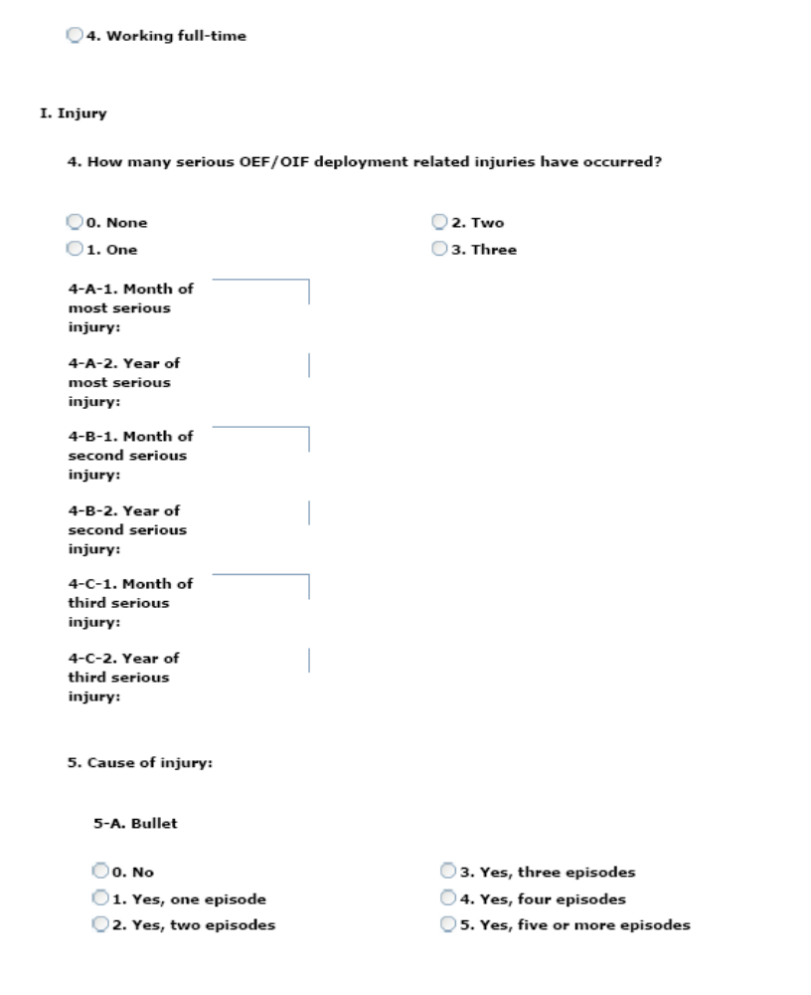
Figure 11 – Comprehensive TBI Evaluation Part 2
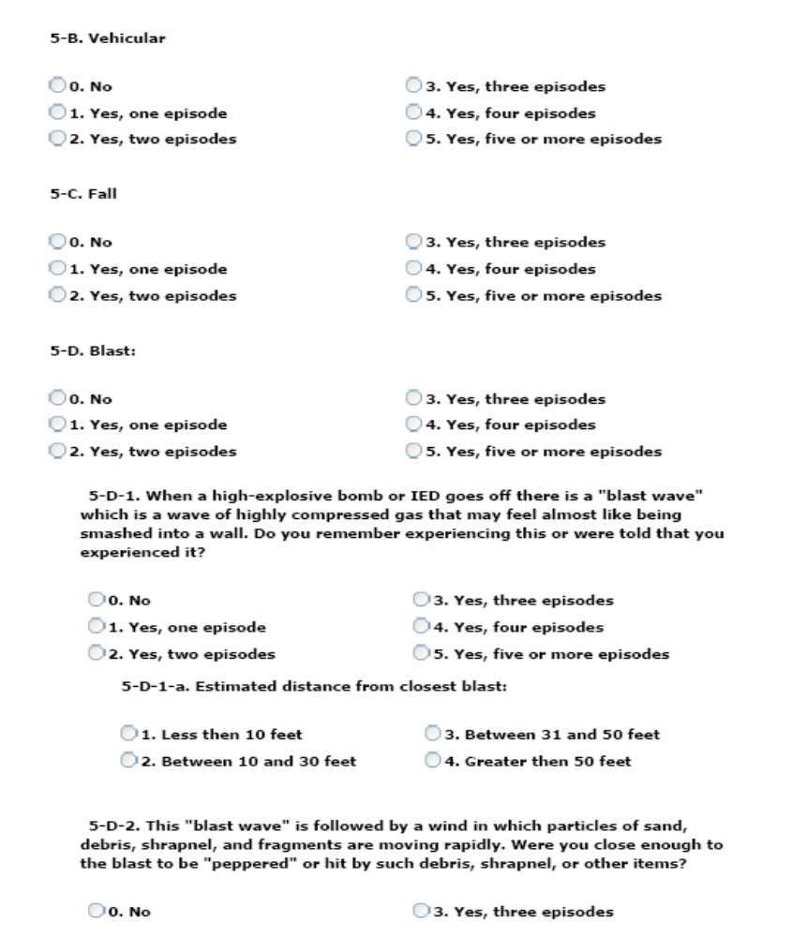
Figure 12 – Comprehensive TBI Evaluation Part 3
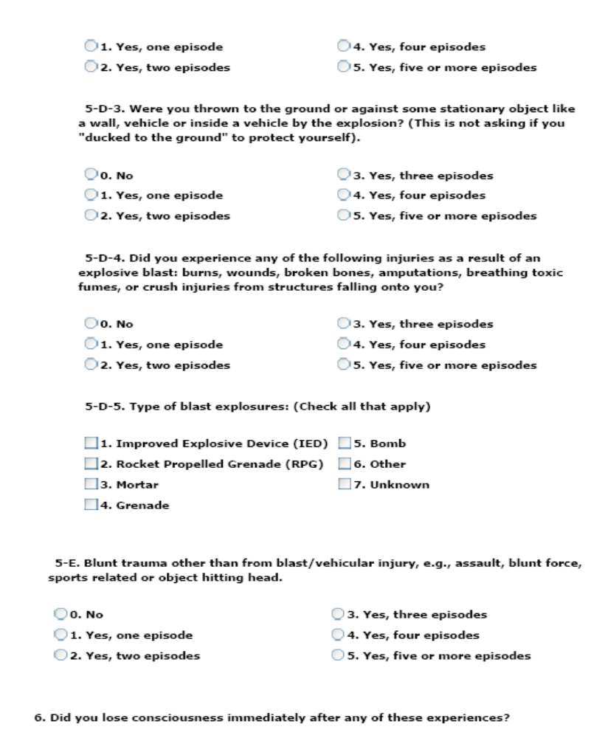
Figure 13 – Comprehensive TBI Evaluation Part 4
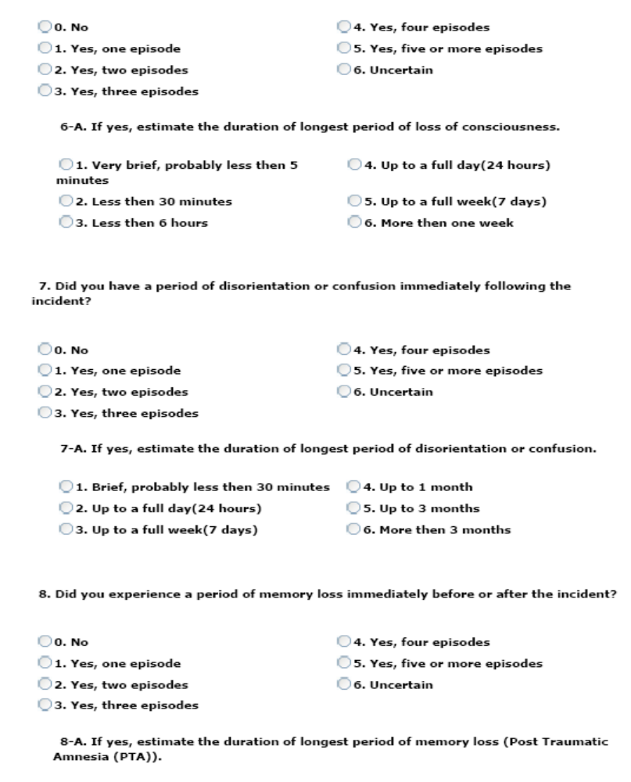
Figure 14 – Comprehensive TBI Evaluation Part 5
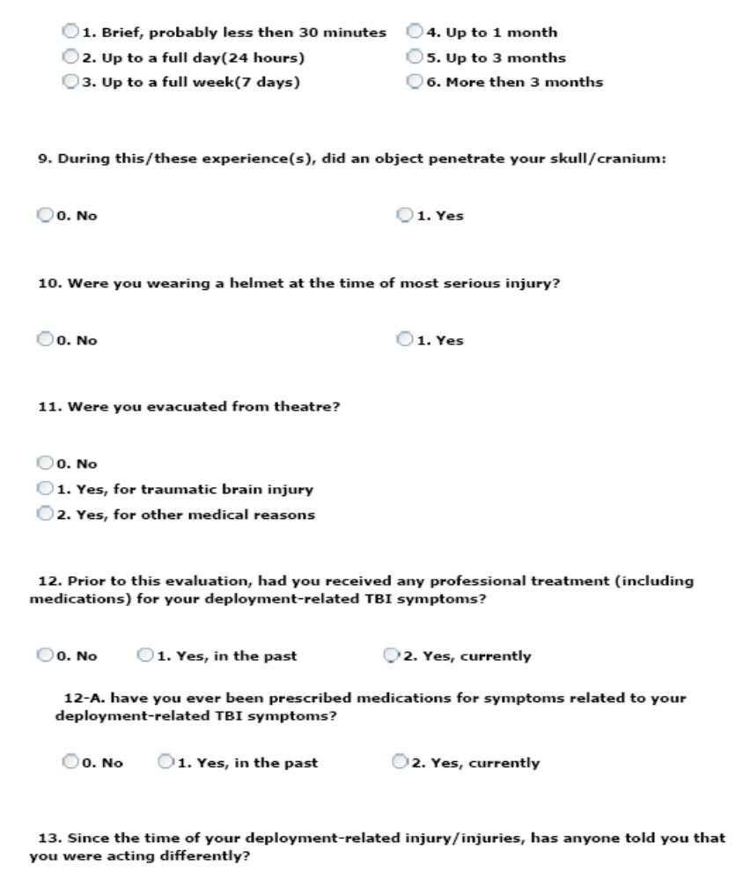
Figure 15 – Comprehensive TBI Evaluation Part 6
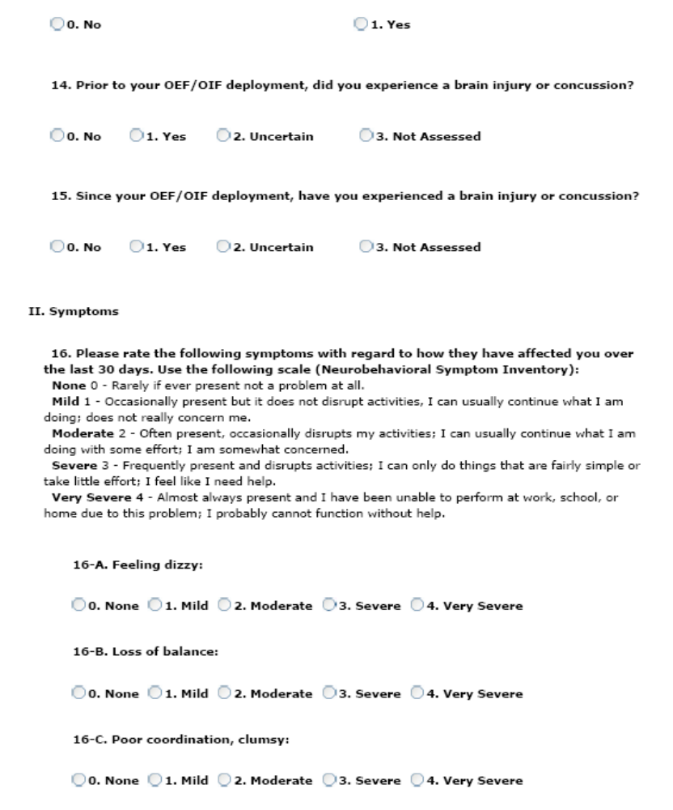
Figure 16 – Comprehensive TBI Evaluation Part 7
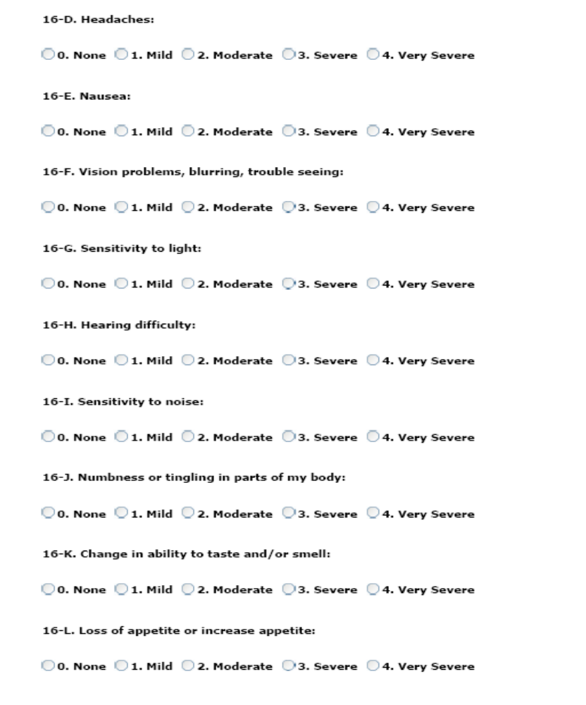
Figure 17 – Comprehensive TBI Evaluation Part 8
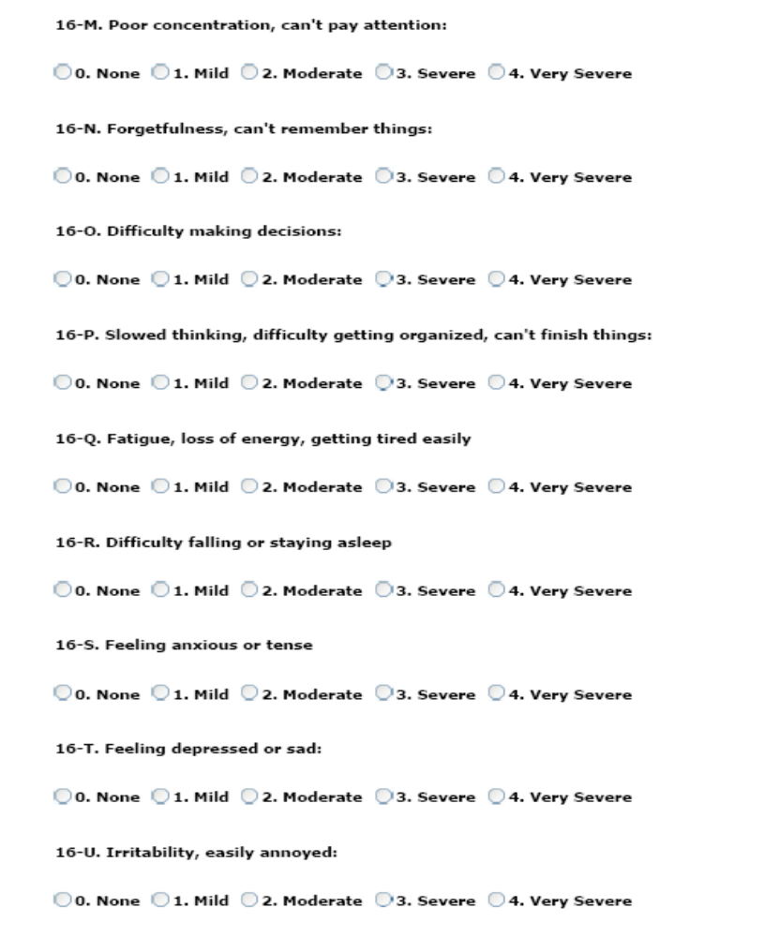
Figure 18 – Comprehensive TBI Evaluation Part 9
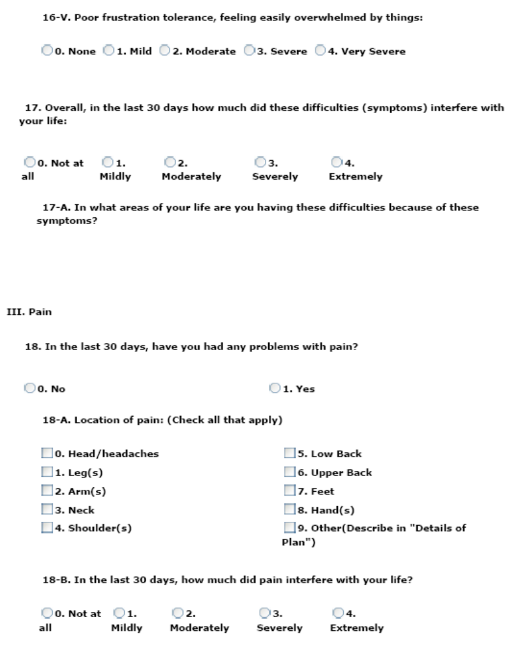
Figure 19 – Comprehensive TBI Evaluation Part 10
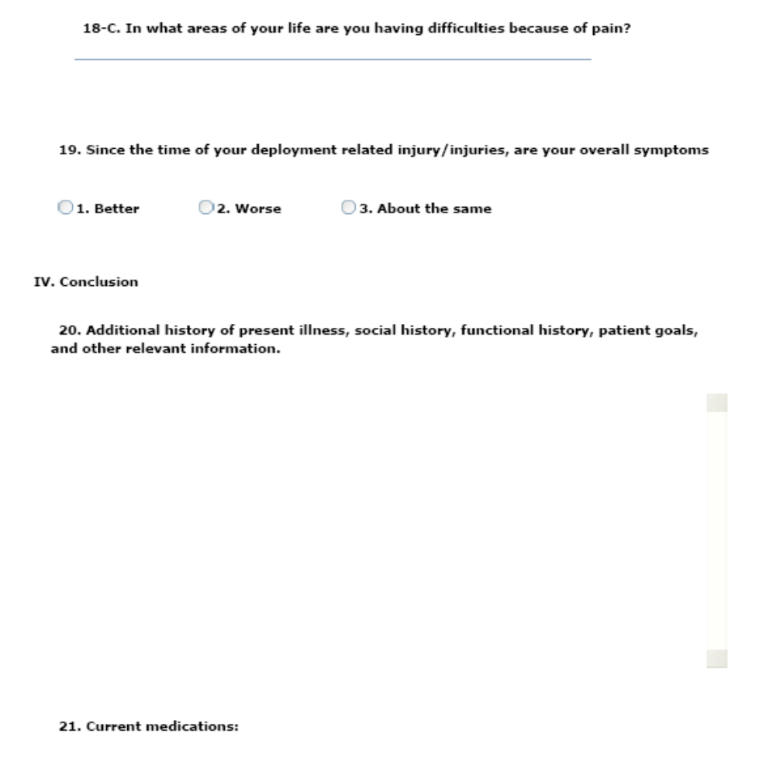
Figure 20 – Comprehensive TBI Evaluation Part 11
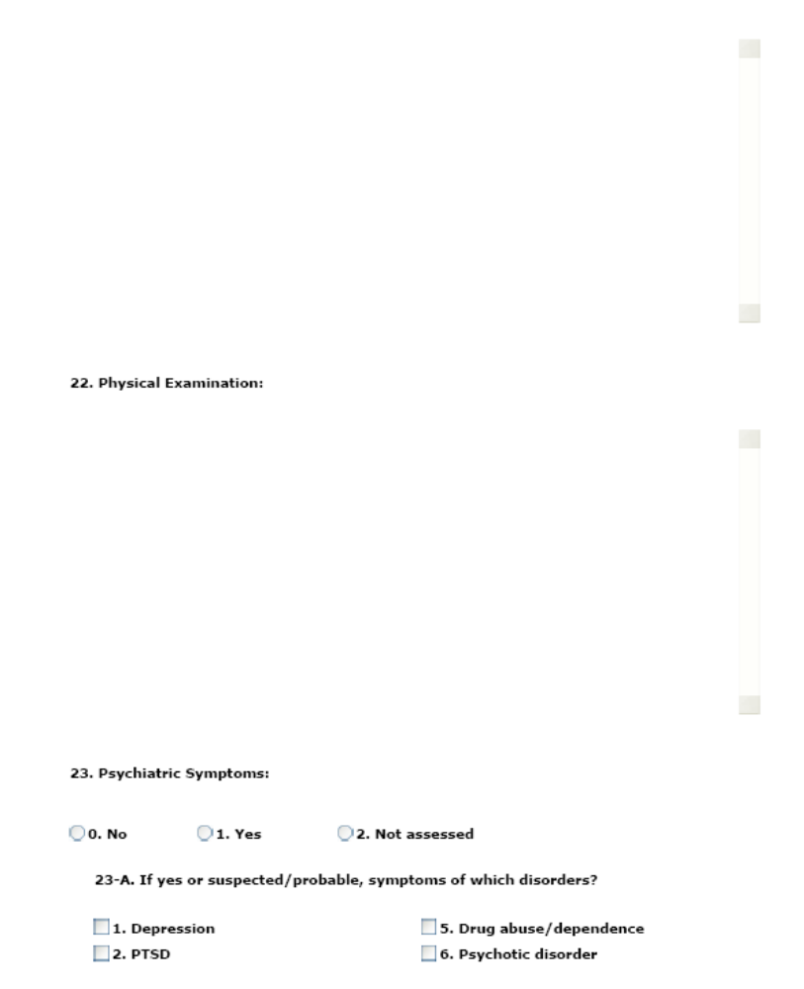
Figure 21 – Comprehensive TBI Evaluation Part 12
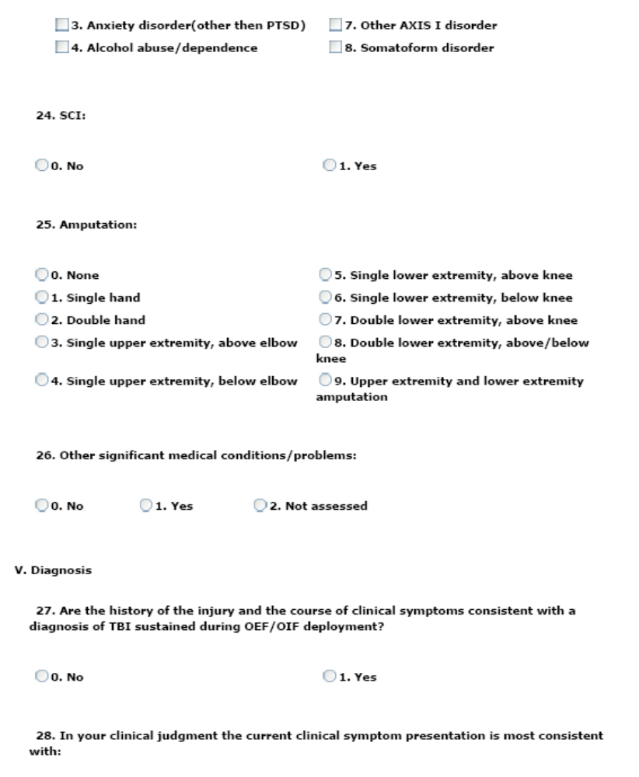
Figure 22 – Comprehensive TBI Evaluation Part 13
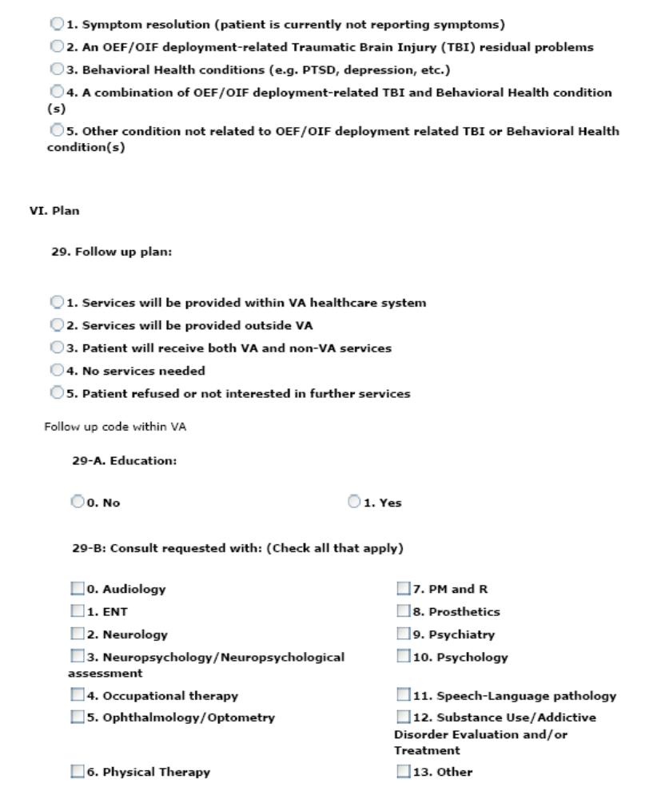
Figure 23 – Comprehensive TBI Evaluation Part 14
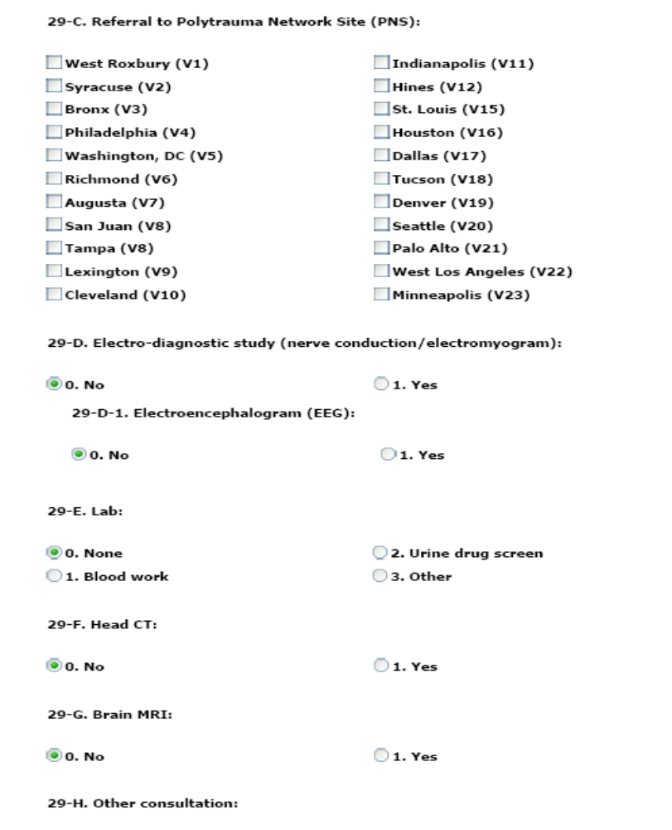
Figure 24 – Comprehensive TBI Evaluation Part 15
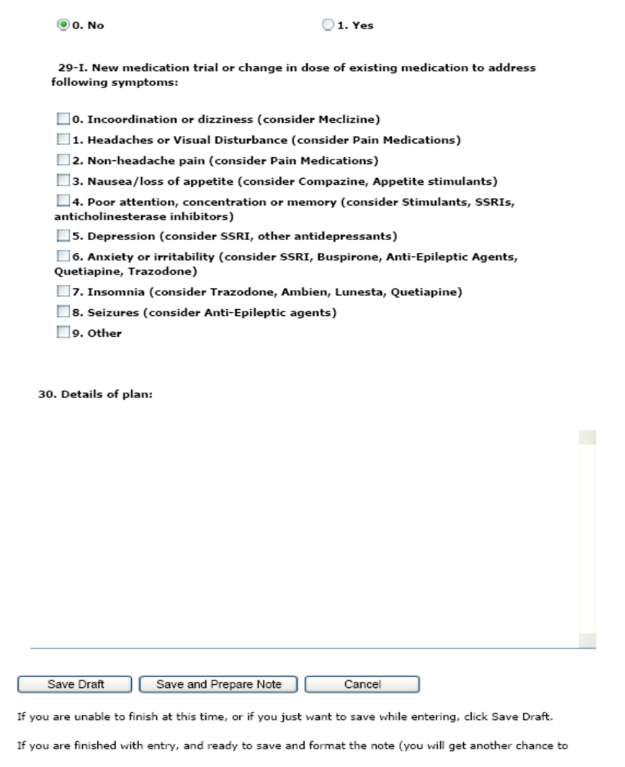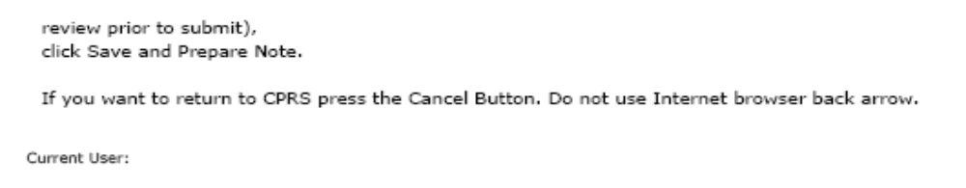
Figure 25 – Comprehensive TBI Evaluation Part 16

Select [Save Draft] to save the information entered even if it is incomplete or in the event the user wishes to review the data again prior to completing the note.
Select [Save and Prepare Note] to preview the note.
Click [Cancel] to reset the questionnaire.
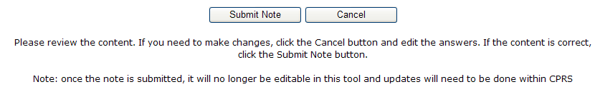
The application reformats the information entered into the questionnaire and displays the resulting report. The instructions on the screen suggest the user review the newly formatted content. If the user wants to make changes to the material, the user should click [Cancel] button and re-enter the answers. If the content is correct, the user clicks the [Submit Note] button.
Be aware that once the note is submitted, it is no longer editable within the TBI Instruments application and any updates will have to be made within CPRS.
The clinician must sign the note in CPRS.

TBI Follow-Up Assessment Screen
The TBI Follow-Up Assessment questionnaire is similar to the Comprehensive TBI Evaluation. Select the appropriate response for each patient.
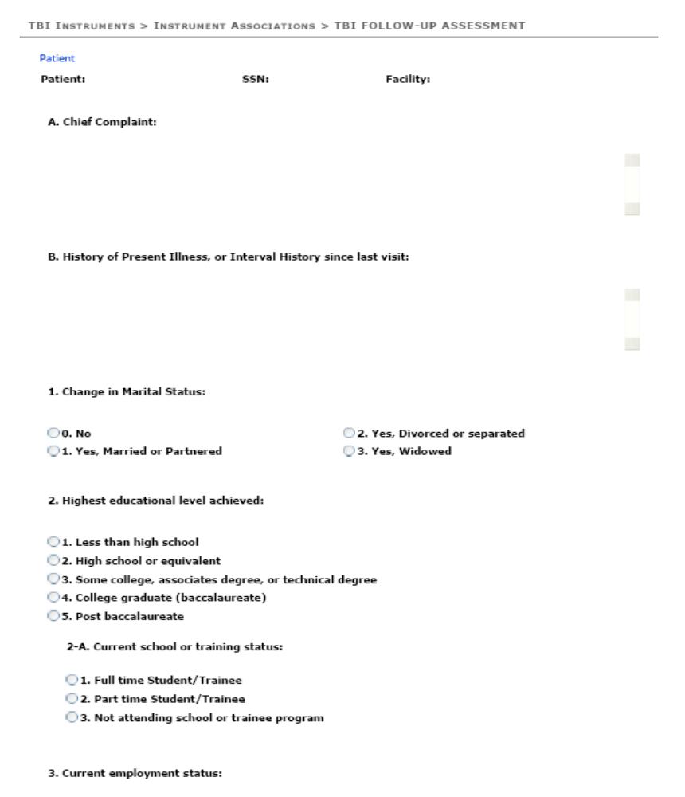
Figure 26 – TBI Follow-Up Assessment Screen Part 1

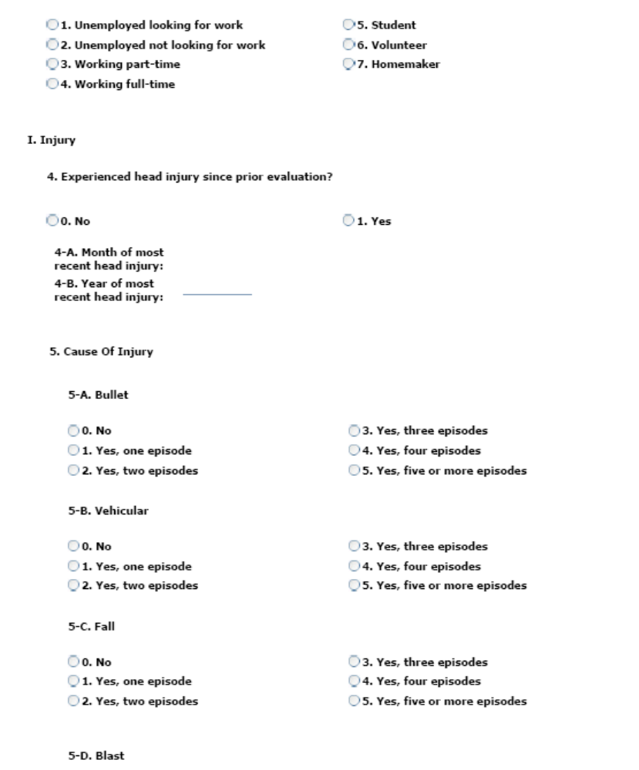
Figure 27 – TBI Follow-Up Assessment Screen Part 2
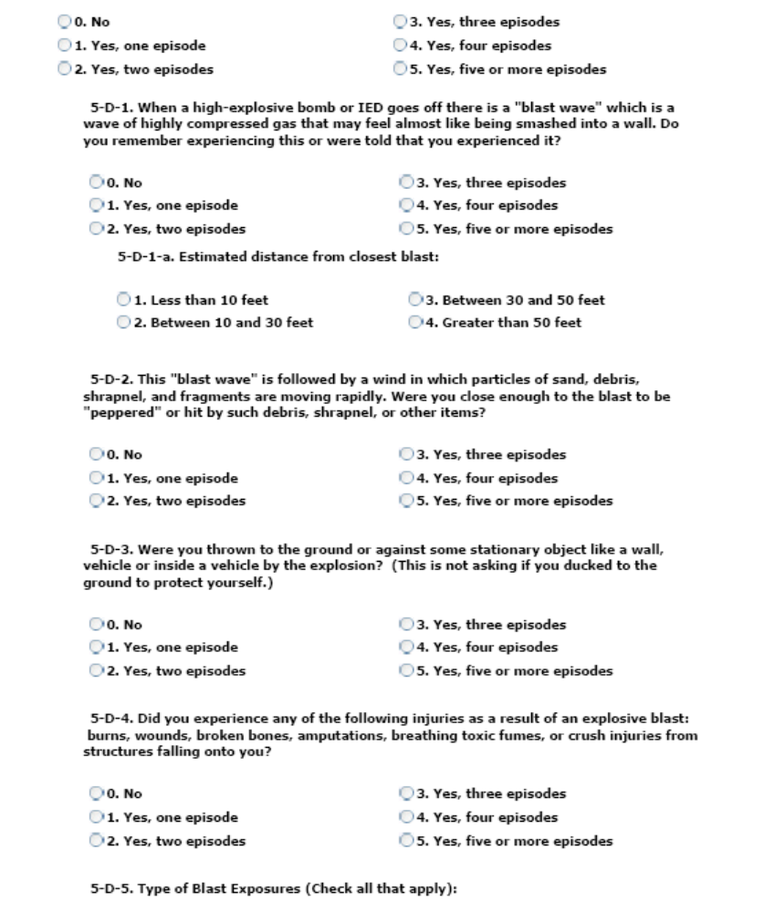
Figure 28 – TBI Follow-Up Assessment Screen Part 3
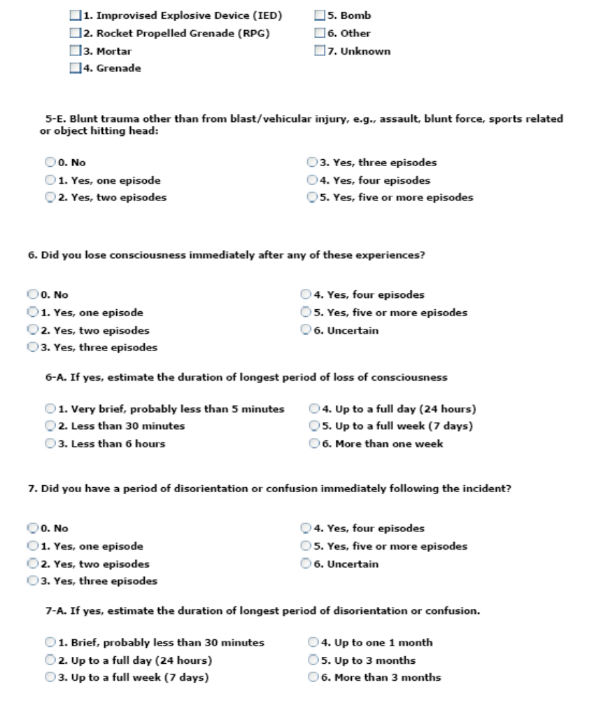
Figure 29 – TBI Follow-Up Assessment Screen Part 4
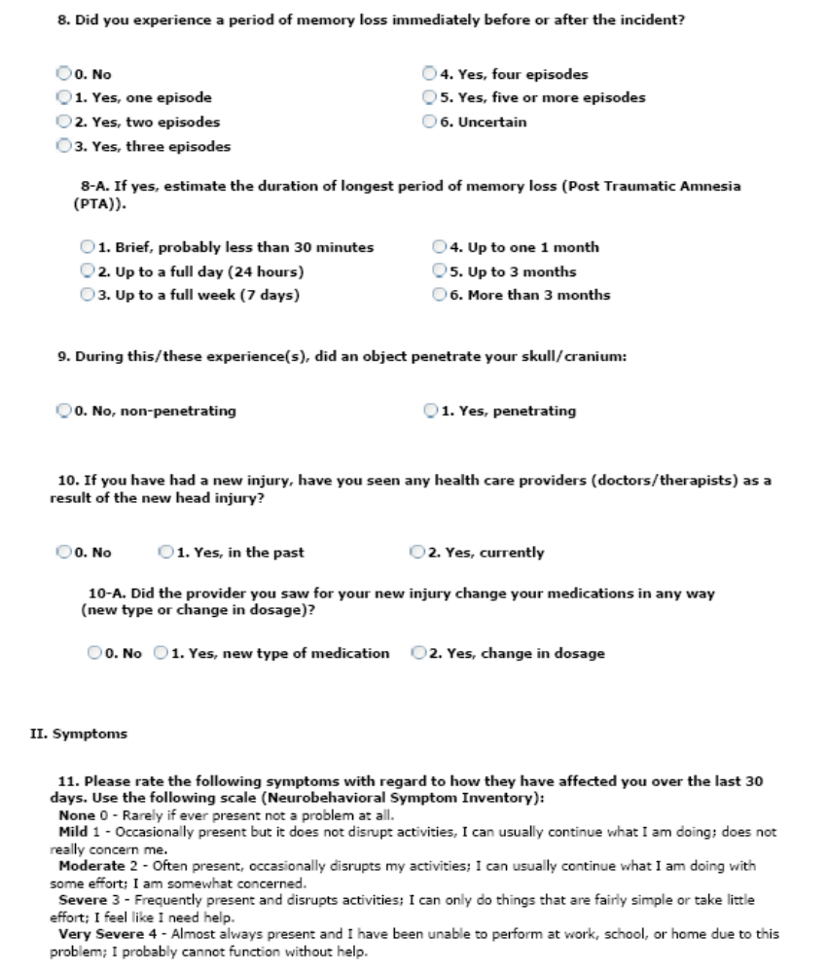
Figure 30 – TBI Follow-Up Assessment Screen Part 5
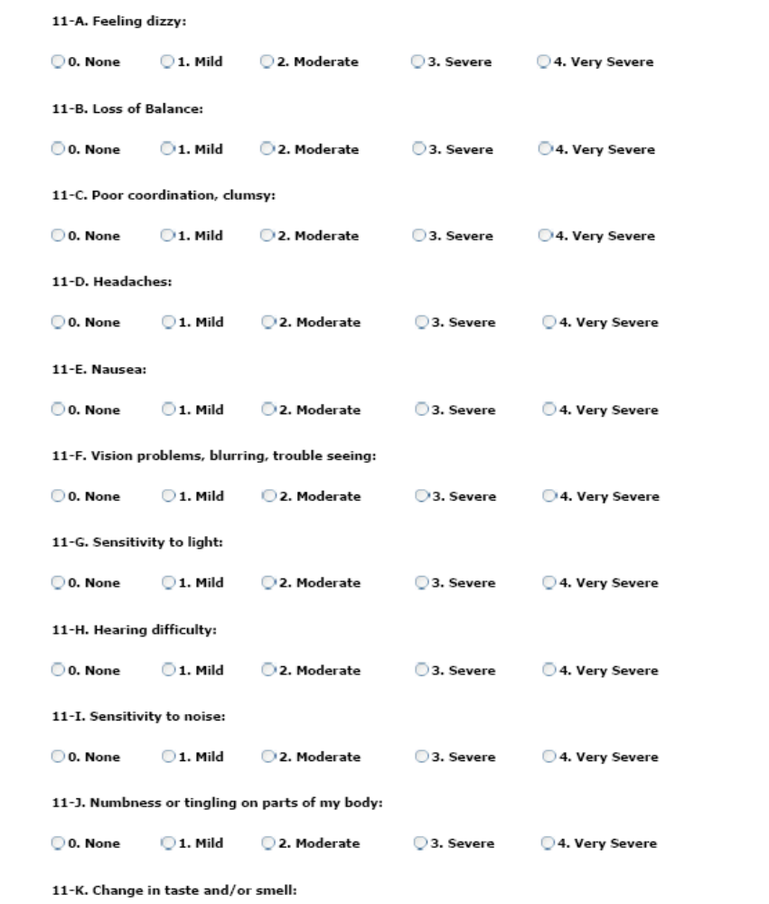
Figure 31 – TBI Follow-Up Assessment Screen Part 6
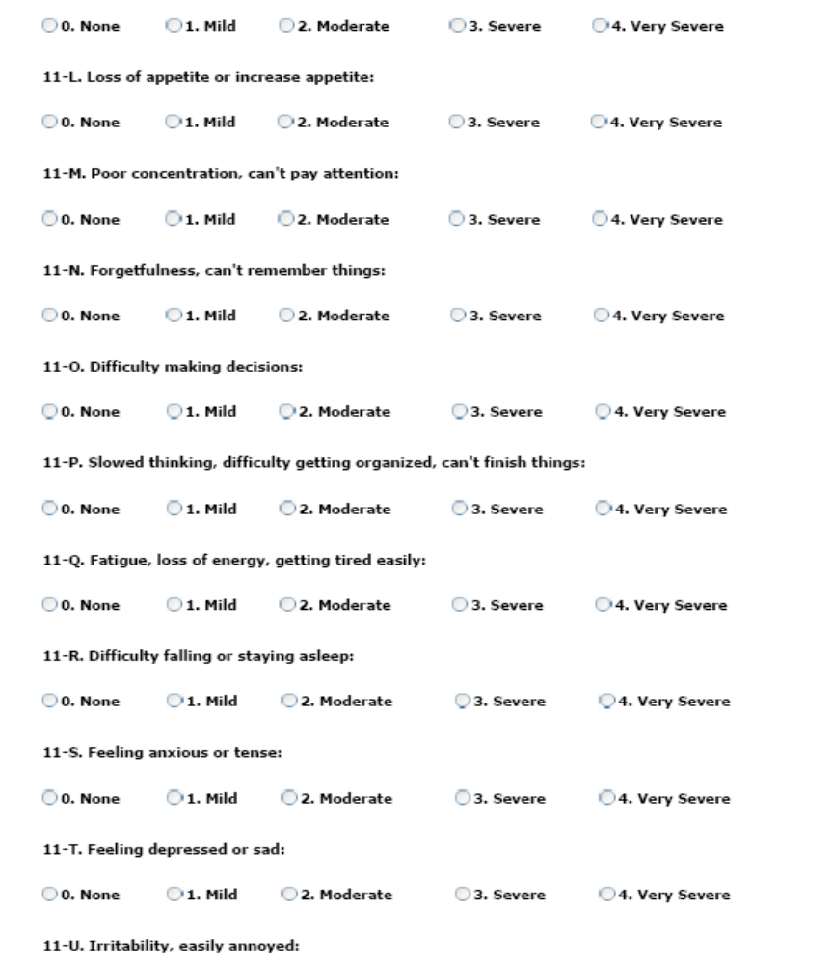
Figure 32 – TBI Follow-Up Assessment Screen Part 7
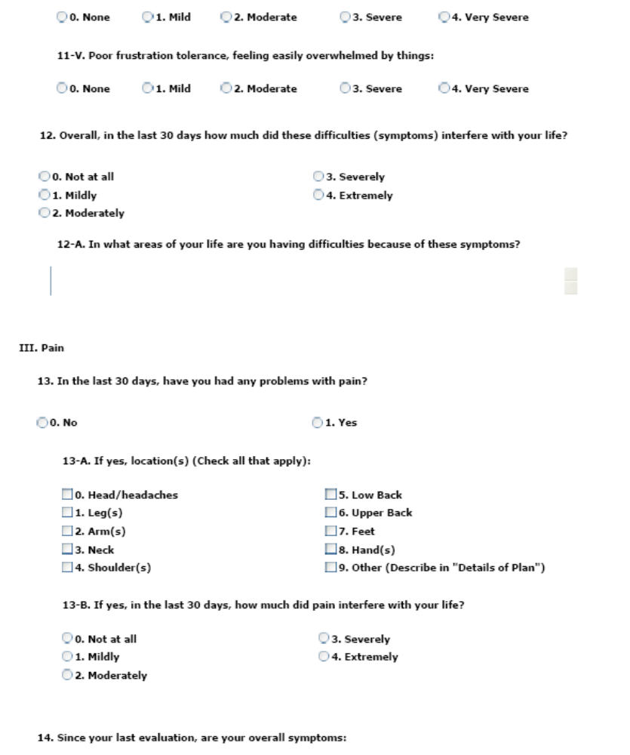
Figure 33 – TBI Follow-Up Assessment Screen Part 8
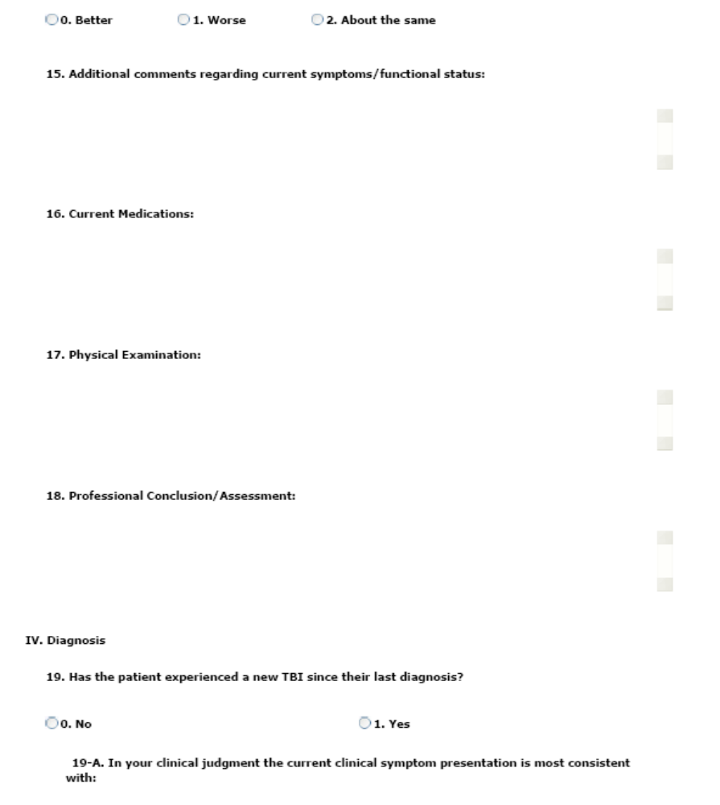
Figure 34– TBI Follow-Up Assessment Screen Part 9
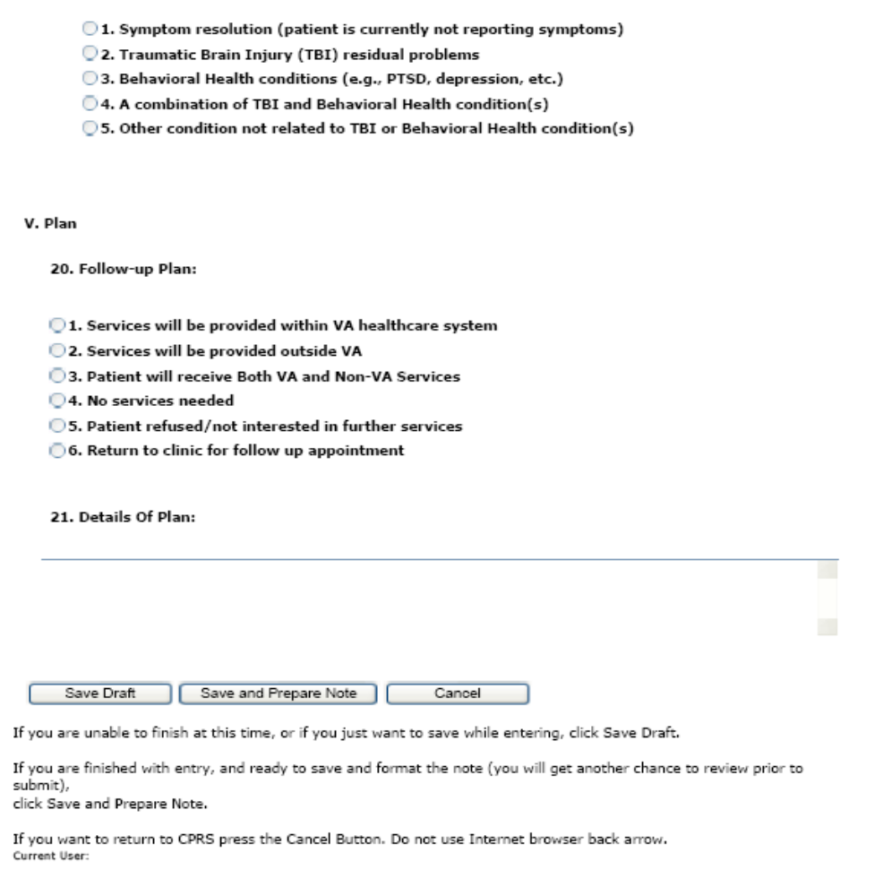
Figure 35 – TBI Follow-Up Assessment Screen Part 10
Select [Save Draft] to save the information entered even if it is incomplete or in the event the user wishes to review the data again prior to completing the note.
Select [Save and Prepare Note] to preview the note.
Click [Cancel] to reset the questionnaire.
The application reformats the information entered into the questionnaire and displays the resulting report. The instructions on the screen suggest the user review the newly formatted content. If the user wants to make changes to the material, the user should click [Cancel] button and re-enter the answers. If the content is correct, the user clicks the [Submit Note] button.
Be aware that once the note is submitted, it is no longer editable within the TBI Instruments application and any updates will have to be made within CPRS.
The clinician must sign the note in CPRS.

Mayo-Portland Adaptability Inventory (MPAI)
MPAI was designed:
- To assist in the clinical evaluation of people during the postacute (posthospital) period following acquired brain injury (ABI),
- To assist in the evaluation of rehabilitation programs designed to serve these people, and
- To better understand the long-term outcomes of ABI.
Evaluation and rating of each of the areas designated by MPAI items assures that the most frequent and important sequelae of ABI are considered for rehabilitation planning or other clinical interventions. MPAI items represent the range of physical, cognitive, emotional, behavioral, and social problems that people may encounter after ABI. MPAI items also provide an assessment of major obstacles to community integration which may result directly from ABI as well as problems in the social and physical environment. Periodic re-evaluation with MPAI during postacute rehabilitation or other intervention provides documentation of progress and of the efficacy and appropriateness of the intervention. Research that examines the responses to the MPAI by individuals with longstanding ABI and by their caregivers and close acquaintances helps to answer questions about the future of those who are newly injured, and their long-term medical, social and economic needs.
Select the appropriate response for each patient. All items are required, except where noted.
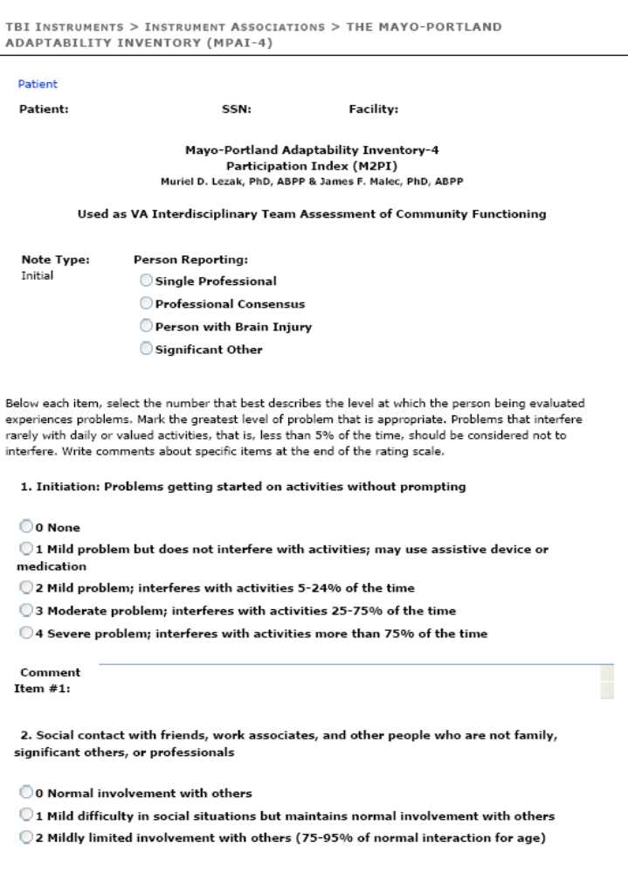
Figure 36 – Mayo Portland Adaptability Inventory Part 1
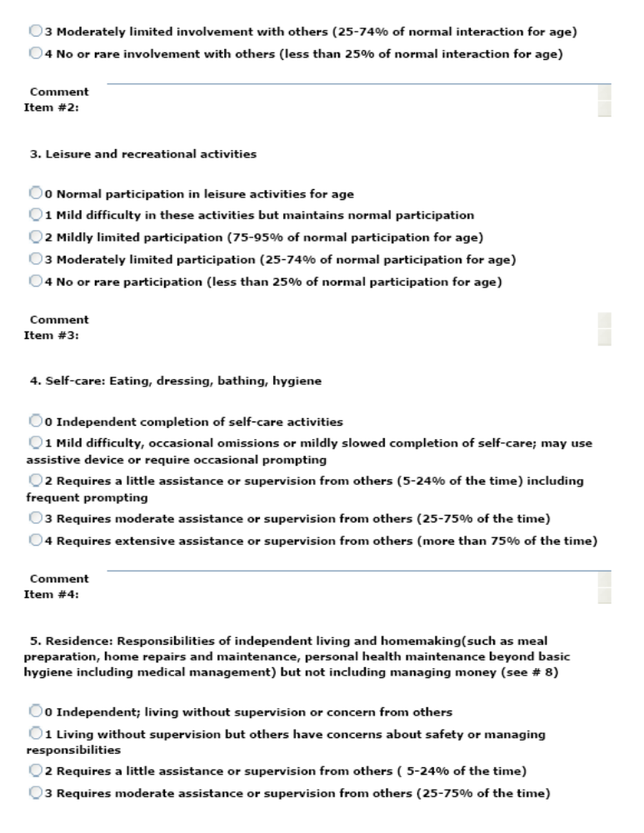
Figure 37 – Mayo Portland Adaptability Inventory Part 2
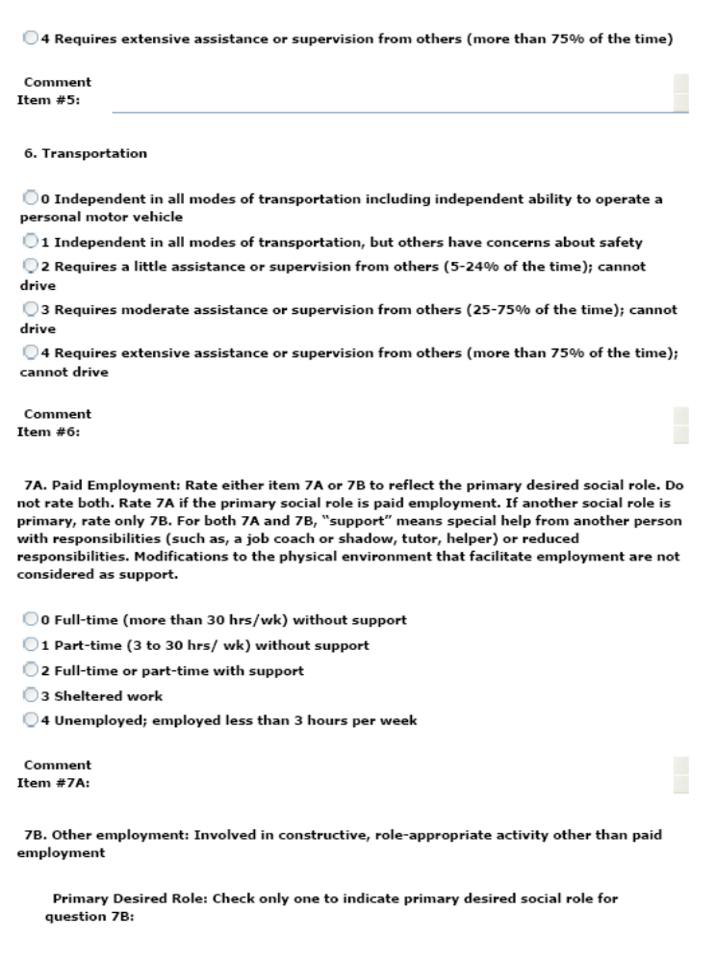
Figure 38 – Mayo Portland Adaptability Inventory Part 3

Note: You can only answer one of Item 7A or 7B. Refer to Figure 19 for the rest of item 7B.
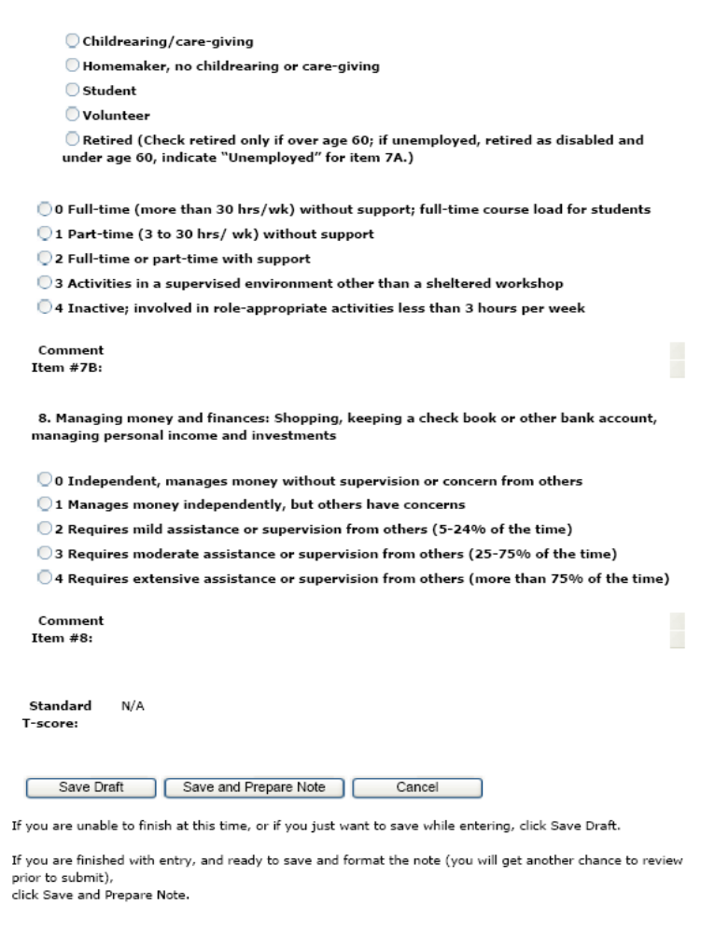
Figure 39 – Mayo Portland Adaptability Inventory Part 4
Select [Save Draft] to save the information entered even if it is incomplete or in the event the user wishes to review the data again prior to completing the note.
Select [Save and Prepare Note] to preview the note.
Click [Cancel] to reset the questionnaire.
The application reformats the information entered into the questionnaire and displays the resulting report. The instructions on the screen suggest the user review the newly formatted content. If the user wants to make changes to the material, the user should click [Cancel] button and re-enter the answers. If the content is correct, the user clicks the [Submit Note] button.
Be aware that once the note is submitted, it is no longer editable within the TBI Instruments application and any updates will have to be made within CPRS.
The clinician must sign the note in CPRS.

Rehabilitation and Reintegration Plan
The Rehabilitation and Community Reintegration Care plan also manages the ongoing and emerging rehabilitation and psychosocial needs of Veterans with polytrauma and TBI. This includes ongoing follow up and treatment, case management, coordination of services, monitoring the implementation of the treatment plan, overseeing the quality and intensity of VA and non-VA services, and providing education and support for patients and caregivers.
Select the appropriate response for each patient.
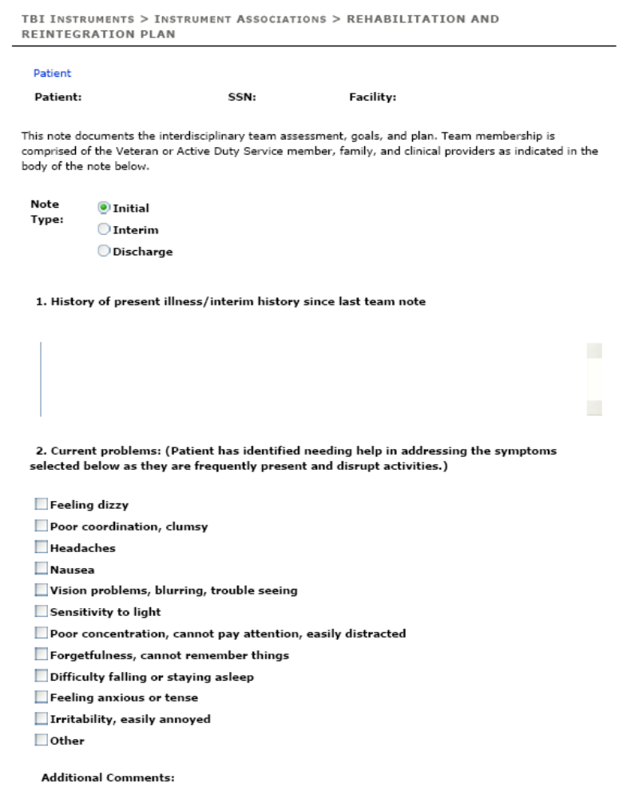
Figure 40 – Rehabilitation and Reintegration Plan Part 1
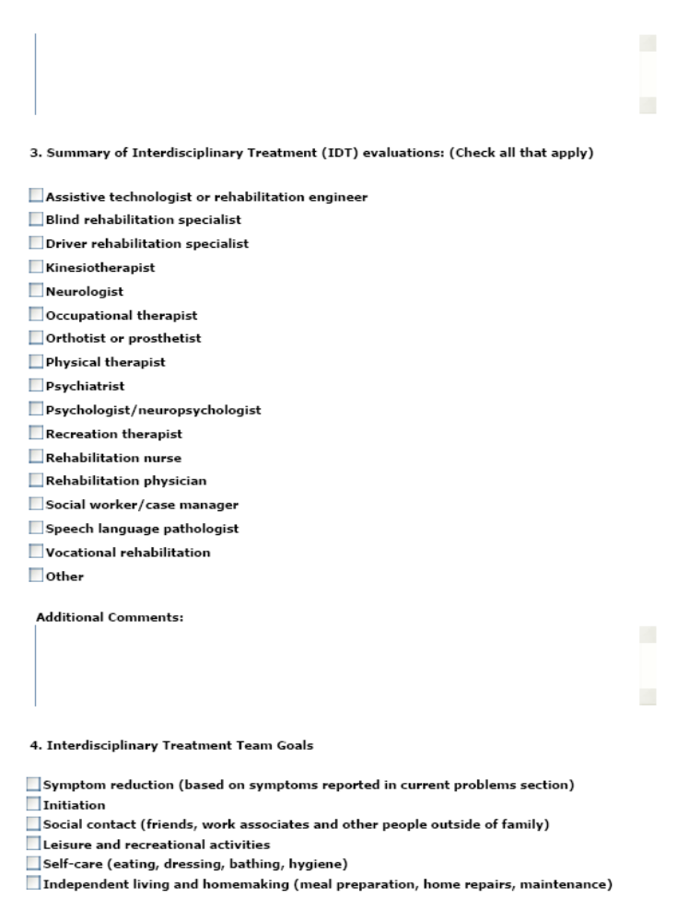
Figure 41 – Rehabilitation and Reintegration Plan Part 2
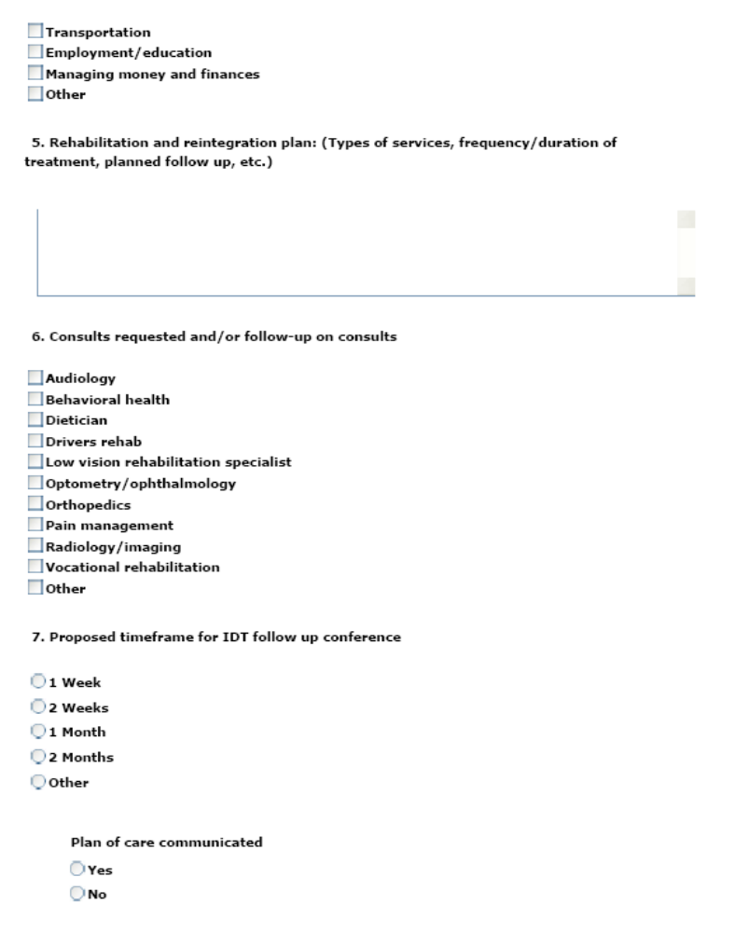
Figure 42 – Rehabilitation and Reintegration Plan Part 3
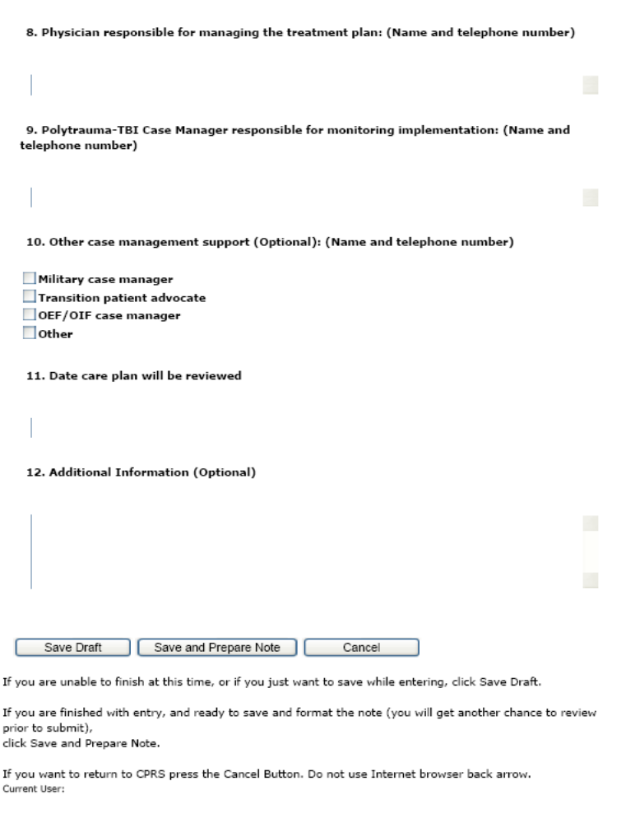
Figure 43 – Rehabilitation and Reintegration Plan Part 4
Select [Save Draft] to save the information entered even if it is incomplete or in the event the user wishes to review the data again prior to completing the note.
Select [Save and Prepare Note] to preview the note.
Click [Cancel] to reset the questionnaire.
The application reformats the information entered into the questionnaire and displays the resulting report. The instructions on the screen suggest the user review the newly formatted content. If the user wants to make changes to the material, the user should click [Cancel] button and re-enter the answers. If the content is correct, the user clicks the [Submit Note] button.
Be aware that once the note is submitted, it is no longer editable within the TBI Instruments application and any updates will have to be made within CPRS.
The clinician must sign the note in CPRS.

Sample Report
The questionnaire answers are summarized and displayed on the screen as shown below. Each report will maintain the same format, however, the questions contained in the report will be specific to each summary. The MAPI Summary is used in this example.
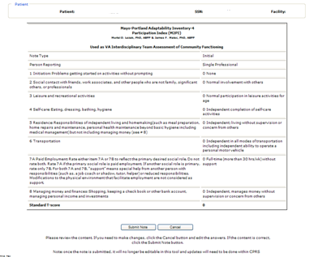
Figure 44 – Sample Report

If the user wants to make changes to the material, the user should click [Cancel] button and re-enter the answers. If the content is correct, the user clicks the [Submit Note] button.
Be aware that once the note is submitted, it is no longer editable within the TBI Instruments application and any updates will have to be made within CPRS.
The clinician must sign the note in CPRS.

- Business Rules
Certain answer to certain questions, or combination of questions, in the questionnaire skip questions and “jump” to other sections of the evaluation. This section details those questions and their effects on the Comprehensive TBI Evaluation and TBI Follow-up Evaluation Instrument.
  - Comprehensive TBI Evaluation Business Rules
Table 3 lists the effect each answer on the Comprehensive TBI Evaluation.
Table 3 – Comprehensive TBI Evaluation Business Rules
Rule | Description | Related Rules
CTE  BR#1 | Answering Yes to Question A skips all questions until question #27.  Then answering No to question #27 produces no error messages and any other data entered for this instrument is presented in the draft note. | - For Question A: Was this evaluation furnished by a non-VA provider, e.g., fee basis? Answer Yes.  - Question #27: Are the history of the injury and the course of clinical symptoms consistent with a diagnosis of TBI sustained during OEF/OIF deployment? Answer No.
CTE  BR#2 | Answering Yes to Question A skips all questions until #27.  Then answering Yes to Question #27 produces no error messages and any other data entered for this instrument is presented in the draft note. | - For Question A: Was this evaluation furnished by a non-VA provider, e.g., fee basis? Answer Yes.  - Question #27. Are the history of the injury and the course of clinical symptoms consistent with a diagnosis of TBI sustained during OEF/OIF deployment?  - Enter Yes for Question #27.
CTE  BR#3 | Answering No to Question A and selecting None for Question #4 will skip questions:  4-A-1, 4-A-2, 4-B-1, 4-B-2, 4-C-1, 4-C-2, 5-A, 5-B, 5-C, 5-D, 5-D-1, 5-D-1-a, 5-D-2, 5-D-3, 5-D-4, 5-D-5, 5-E, 6, 6-A, 7, 7-A, 8, 8-A, 9, 10, 11, 12, 12-A, 13. | - For Question A: Was this evaluation furnished by a non-VA provider, e.g., fee basis? Answer No.  - For Question #4: How many serious OEF/OIF deployment related injuries have occurred? Answer None.  - The system skips questions:  4-A-1, 4-A-2, 4-B-1, 4-B-2, 4-C-1, 4-C-2, 5-A, 5-B, 5-C, 5-D, 5-D-1, 5-D-1-a, 5-D-2, 5-D-3, 5-D-4, 5-D-5, 5-E, 6, 6-A, 7, 7-A, 8, 8-A, 9, 10, 11, 12, 12-A, 13  - Answering Yes in this scenario produces the following message:  In question #4, your response indicates this patient did not experience an OEF/OIF deployment related injury. Based on this response, this patient would not have suffered an OEF/OIF deployment related TBI. If your response to question #4 is not correct, and this patient did experience an OEF/OIF deployment related injury, please make the appropriate correction to question #4, and you will then be permitted to indicate the patient suffered a TBI during OEF/OIF deployment.
CTE  BR#4 | Answering No to Question A and selecting One for Question #4 will skip questions 4-B-1, 4-B-2, 4-C-1, 4-C-2. | - For question A: Was this evaluation furnished by a non-VA provider, e.g., fee basis? Answer No.  - For Question #4: How many serious OEF/OIF deployment related injuries have occurred? Answer One.  - The result is:  - The Year allowed is 2001 to current.  - The system skips questions:  4-B-1, 4-B-2, 4-C-1, 4-C-2
CTE  BR#5 | Answering No to question A and selecting One for question #4 will skip questions 4-C-1, 4-C-2. | - For Question A: Was this evaluation furnished by a non-VA provider, e.g., fee basis? Answer No.  - For Question #4: How many serious OEF/OIF deployment related injuries have occurred? Answer Two.  - The result is:  - The Year allowed is 2001 to current.  - The system skips questions: 4-C-1, 4-C-2  - If you answered Question #4 with Three, you will be allowed to go to 4-C-1 and 4-C-2 and the Year allowed is 2001 to current.
CTE  BR#6 | Answering No to Question A and Enter/confirm there is something other than 0.No. Then answering No for question 4, and No for question 5-D will skip questions 5-D-1, 5-D-1-a, 5-D-2, 5-D-3, 5-D-4, 5-D-5. | - For Question A: Was this evaluation furnished by a non-VA provider, e.g., fee basis? Answer No.  - Enter or confirm the answer for Question for is something other than "0. No".  - For question #5-D. Blast: Answer No.  - The result is:  - The system skips questions: 5-D-1, 5-D-1-a, 5-D-2, 5-D-3, 5-D-4, 5-D-5.  - Answering No on 5-D moves you to question 5-E.
CTE  BR#7 | Answering No to Question A and Question #6, will skip question 6-A. | - For Question A: Was this evaluation furnished by a non-VA provider, e.g., fee basis? Answer No.  - For Question #6: Did you lose consciousness immediately after any of these experiences? Answer No.  - The system will skip 6-A
CTE  BR#8 | Answering No to Question A and answering Uncertain to Question #6, will skip Question 6-A. | - For Question A: Was this evaluation furnished by a non-VA provider, e.g., fee basis? Answer No.  - For Question #6: Did you lose consciousness immediately after any of these experiences? Answer Uncertain.  - The system will skip question 6-A.
CTE  BR#9 | Answering No to Question A and Question #7 will skip question 7-A. | - For Question A: Was this evaluation furnished by a non-VA provider, e.g., fee basis? Answer No.  - For Question #7: Did you have a period of disorientation or confusion immediately following the incident? Answer No.  - The system will skip question 7-A.
CTE  BR#10 | Answering No to Question A and answering Uncertain to Question #6, will skip Question 7-A. | - For question A: Was this evaluation furnished by a non-VA provider, e.g., fee basis? Answer No.  - For Question #7: Did you have a period of disorientation or confusion immediately following the incident? Answer Uncertain.  - The system will skip question 7-A.
CTE  BR#12 | Answering No to Question A and answering Uncertain to Question #8, will skip Question 8-A. | - For question A: Was this evaluation furnished by a non-VA provider, e.g., fee basis? Answer No.  - For Question #8: Did you experience a period of memory loss immediately before or after the incident? Answer Uncertain.  - The system will skip Question 8-A.
CTE  BR#13 | Answering No to Question A and Question #12, will skip question 12-A. | - For Question A: Was this evaluation furnished by a non-VA provider, e.g., fee basis? Answer No.  - For Question #12: Prior to this evaluation, had you received any professional treatment (including medications) for your deployment related TBI symptoms? Answer No.  - The system will skip question 12-A.
CTE  BR#14 | Answering No to question A and Not at all to Question #17, will skip question 17-A. | - For Question A: Was this evaluation furnished by a non-VA provider, e.g., fee basis? Answer No.  - For Question 17: Overall, in the last 30 days how much did these difficulties (symptoms) interfere with your life? Answer Not at all.  - The system will skip question 17-A.
CTE  BR#15 | Answering No to Questions A and #18, will skip questions 18-A, 18-B, 18-C. | - For Question A: Was this evaluation furnished by a non-VA provider, e.g., fee basis? Answer No.  - For Question 18. In the last 30 days, have you had any problems with pain? Answer No.  - The system will skip questions 18-A, 18-B, 18-C.
CTE  BR#16 | Answering No to Question A and Not at all to Question #18-B, will skip question 18-C. | - For question A: Was this evaluation furnished by a non-VA provider, e.g., fee basis? Answer No.  - For Question 18-B. In the last 30 days, how much did pain interfere with your life? Answer Not at all.  - The system will skip question 18-C
CTE  BR#17 | Answering No to Question A and Not at all to Question #23, will skip Question 23-A. | - For question A: Was this evaluation furnished by a non-VA provider, e.g., fee basis? Answer No.  - For question 23. Psychiatric Symptoms: Answer Not at all.  - The system will skip question 23-A.
CTE  BR#18 | Answering No to Question A and select something that does not equal Other condition not related to OEF/OIF deployment related TBI or Behavioral Health conditions(s) for Question #28, will skip Question 28-A. | - For question A: Was this evaluation furnished by a non-VA provider, e.g., fee basis? Answer No.  - For Question 28: In your clinical judgment the current clinical symptom presentation is most consistent with: Answer anything other than Other condition not related to OEF/OIF deployment related TBI or Behavioral Health conditions(s).  - The system will skip question 28-A.
CTE  BR#19 | Answering No to Question A and Services will be provided outside VA. to Question #29, will skip questions 29-A, 29-B, 29-C, 29-D, 29-D-1, 29-E, 29-F, 29-G, 29-H, 29-I, 29-I-1, 30. | - For question A. Was this evaluation furnished by a non-VA provider, e.g., fee basis? Answer No.  - For Question 29. Follow up plan: Answer Services will be provided outside VA.  - The system will skip questions 29-A, 29-B, 29-C, 29-D, 29-D-1, 29-E, 29-F, 29-G, 29-H, 29-I, 29-I-1, 30.
CTE  BR#20 | Answering No to Question A No services needed to question #29, will skip questions 29-A, 29-B, 29-C, 29-D, 29-D-1, 29-E, 29-F, 29-G, 29-H, 29-I, 29-I-1, 30. | - For Question A: Was this evaluation furnished by a non-VA provider, e.g., fee basis? Answer No.  - For Question 29. Follow up plan: Answer No services needed.  - The system will skip questions 29-A, 29-B, 29-C, 29-D, 29-D-1, 29-E, 29-F, 29-G, 29-H, 29-I, 29-I-1, 30.
CTE  BR#21 | Answering No to Question A and Patient refused or not interested in further services to question #29, will skip questions 29-A, 29-B, 29-C, 29-D, 29-D-1, 29-E, 29-F, 29-G, 29-H, 29-I, 29-I-1, 30. | - For Question A: Was this evaluation furnished by a non-VA provider, e.g., fee basis? Answer No.  - For Question 29. Follow up plan: Answer Patient refused or not interested in further services.  - The system will skip question 29-A, 29-B, 29-C, 29-D, 29-D-1, 29-E, 29-F, 29-G, 29-H, 29-I, 29-I-1, 30.
CTE  BR#22 | Answering No to Question A and answering something other than Other for Question #29-I, will skip question 29-I-1. | - For Question A. Was this evaluation furnished by a non-VA provider, e.g., fee basis? Answer No.  - For Question 29-I. New medication trial or change in dose of existing medication to address the following symptoms: Answer something other than Other.  - The system will skip question 29-I-1.

  - TBI Follow-up Evaluation Instrument Business Rules
Table 4 lists the effect each answer on the TBI Follow-up Evaluation Instrument
Table 4 – TBI Evaluation Instrument Business Rules
Rule | Description | Related Rules
TFA  BR#1 | Answering No to Question #4 will skip Questions 4-A, 4-B, 5-A, 5-B, 5-C, 5-D, 5-D-1, 5-D-1-A, 5-D-2, 5-D-3, 5-D-4, 5-D-5, 5-E, 6, 6-A, 7, 7-A, 8, 8-A, 9, 10, 10-A. | - For Question 4: Experienced head injury since prior evaluation? Answer No.  - The system will skip questions 4-A, 4-B, 5-A, 5-B, 5-C, 5-D, 5-D-1, 5-D-1-A, 5-D-2, 5-D-3, 5-D-4, 5-D-5, 5-E, 6, 6-A, 7, 7-A, 8, 8-A, 9, 10, 10-A
TFA  BR#2 | Answering No to Question #5-D will skip Questions 5-D-1, 5-D-1-A, 5-D-2, 5-D-3, 5-D-4, 5-D-5 | - For question 5-D. "Blast:" Answer No.  - The system will skip of questions 5-D-1, 5-D-1-A, 5-D-2, 5-D-3, 5-D-4, 5-D-5.
TFA  BR#3 | Answering No to Question #6 will skip questions 6-A. | - For question 6: Did you lose consciousness immediately after any of these experiences? Answer No.  - The system will skip Question 6-A
TFA  BR#4 | Answering Uncertain to Question #6 will skip Question 6-A. | - For question 6: Did you lose consciousness immediately after any of these experiences? Answer Uncertain.  - The system will skip Question 6-A
TFA  BR#5 | Answering No to Question #7 will skip Question 7-A. | - For question 7: Did you have a period of disorientation or confusion immediately following the incident? Answer No.  - The system will skip question 7-A.
TFA  BR#6 | Answering Uncertain to Question #7 will skip Question 7-A. | - For question 7: Did you have a period of disorientation or confusion immediately following the incident? Answer Uncertain.  - The system will skip question 7-A
TFA  BR#7 | Answering No to Question #8 will skip Question 8-A. | - For question 8: Did you experience a period of memory loss immediately before or after the incident? Answer No.  - The system will skip question 8-A
TFA  BR#8 | Answering Uncertain to Question #8 will skip Question 8-A. | - For question 8: Did you experience a period of memory loss immediately before or after the incident? Answer Uncertain.  - The system will skip question 8-A.
TFA  BR#9 | Answering No to Question #10 will skip Questions 10-A. | - For question 10: If you have had a new injury, have you seen any health care providers (doctors/therapists) as a result of the new head injury? Answer No.  - The system will skip question 10-A
TFA  BR#10 | Answering Uncertain to Question #8 will skip Question 8-A. | - For question 8: Did you experience a period of memory loss immediately before or after the incident? Answer Uncertain.  - The system will skip question 8-A
TFA  BR#11 | Answering anything other than Other to Question #20-A will skip Question 20-A-1.  Answer Other on Question #20-A, Question 20-A-1 will appear. | - For Question 20-A, answer anything other than "Other". The system will skip Question 20-A-1.  - For Question 20-A, answer "Other". Question 20-A-1 appears.
TFA  BR#12 | Answering No to Question #13 will skip Questions 13-A, 13-B | - For Question 13: In the last 30 days, have you had any problems with pain? Answer No.  - The system will skip questions 13-A, 13-B

- Glossary

Glossary
A | B | C | D | E | F | G | H | I | J | K | L | M
N | O | P | Q | R | S | T | U | V | W | X
0-9
Control-click character to see entries; missing character means no entries for that character.

Term or Acronym |  |  |  |  | Description
0 - 9
508 |  |  | See Section 508
BACK | to Glossary Contents
Term or Acronym |  |  |  | Description
A
ABI |  | Acquired Brain Injury
BACK | to Glossary Contents

Term or Acronym |  | Description
B
browser |  | A program which allows a person to read hypertext. The browser provides some means of viewing the contents of nodes (or "pages") and of navigating from one node to another. A browser is required in order to access the TBI software application.  Microsoft® Internet Explorer® and Firefox® are examples for browsers for the World-Wide Web. They act as clients to remote web servers.
BACK | to Glossary Contents

Term or Acronym |  | Description
C
Case |  | The collection of information maintained on patients that have been included in a registry.
Computerized Patient Record System (CPRS) |  | A Computerized Patient Record (CPR) is a comprehensive database system used to store and access patients’ healthcare information. CPRS is the Department of Veterans Affairs electronic health record software. The CPRS organizes and presents all relevant data on a patient in a way that directly supports clinical decision making. This data includes medical history and conditions, problems and diagnoses, diagnostic and therapeutic procedures and interventions. Both a graphic user interface version and a character-based interface version are available. CPRS provides a single interface for health care providers to review and update a patient’s medical record, and to place orders, including medications, special procedures, x-rays, patient care nursing orders, diets, and laboratory tests. CPRS is flexible enough to be implemented in a wide variety of settings for a broad spectrum of health care workers, and provides a consistent, event-driven, Windows-style interface.
CPRS |  | See Computerized Patient Record System
BACK | to Glossary Contents

Term or Acronym | Description
D
Department of Defense (DoD) | A department of the U.S. Federal government, charged with ensuring that the military capacity of the U.S. is adequate to safeguard the national security.
DoD | See Department of Defense
BACK | to Glossary Contents

Term or Acronym |  | Description
E
BACK | to Glossary Contents

Term or Acronym |  | Description
F
BACK | to Glossary Contents

Term or Acronym |  |  | Description
G
Global War On Terror (GWOT) |  | Obsolete term; see Overseas Contingency Operation
GWOT |  | Global War On Terror (obsolete term; see Overseas Contingency Operation).
BACK | to Glossary Contents

Term or Acronym |  |  | Description
H
BACK | to Glossary Contents

Term or Acronym |  |  | Description
I
BACK |  | to Glossary Contents

Term or Acronym |  |  | Description
J
BACK | to Glossary Contents

Term or Acronym |  |  | Description
K
BACK | to Glossary Contents

Term or Acronym |  |  | Description
L
BACK | to Glossary Contents

Term or Acronym |  |  | Description
M
MAPI |  | Mayo-Portland Adaptability Inventory
BACK | to Glossary Contents

Term or Acronym |  | Description
N
BACK | to Glossary Contents

Term or Acronym |  | Description
O
OCO |  | See Overseas Contingency Operation
OEF/OIF |  | Operation Enduring Freedom/Operation Iraqi Freedom
OPCS |  | See Patient Care Services
OIT |  | Office of Information Technology
BACK | to Glossary Contents

Term or Acronym |  |  | Description
P
Patient Care Services (PCS), Office of |  | OPCS oversees VHA's clinical programs that support and improve Veterans' health care. The VA's broad approach to Veteran care incorporates expert knowledge, clinical practice and patient care guidelines in all aspects of care.
BACK | to Glossary Contents

Term or Acronym | Description
Q

Term or Acronym |  |  | Description
R
Registry |  | The VHA Registries Program supports the population-specific data needs of the enterprise including (but not limited to) the Defense/Veterans Eye Injury Registry, Oncology Tumor Registry, Traumatic Brain Injury Registry, Embedded Fragment Registry and Eye Trauma Registry.  Also, a database containing a collection of data relating to a disease or condition.
BACK | to Glossary Contents

Term or Acronym |  |  | Description
S
Section 508 |  | Section 508 of the Rehabilitation Act as amended, 29 U.S.C. Section 794(d), requires that when Federal agencies develop, procure, maintain, or use electronic and information technology, they shall ensure that this technology is accessible to people with disabilities. Agencies must ensure that this technology is accessible to employees and members of the public with disabilities to the extent it does not pose an “undue burden.” Section 508 speaks to various means for disseminating information, including computers, software, and electronic office equipment.  The TBI must be 508 compliant, able to extract data as needed including SNOMED codes.
Surveillance |  | Systematic collection, analysis, and interpretation of health data about a disease or condition.
Systematized Nomenclature of Medicine (SNOMED) |  | SNOMED is a terminology that originated as the systematized nomenclature of pathology (SNOP) in the early 1960s under the guidance of the College of American Pathologists. In the late 1970s, the concept was expanded to include most medical domains and renamed SNOMED. The core content includes text files such as the concepts, Descriptions, relationships, ICD-9 mappings, and history tables. SNOMED represents a terminological resource that can be implemented in software applications to represent clinically relevant information comprehensive (>350,000 concepts) multi-disciplinary coverage but discipline neutral structured to support data entry, retrieval, maps, etc.
BACK | to Glossary Contents

Term or Acronym |  |  | Description
T
TBI |  | See Traumatic Brain Injuries
Traumatic Brain Injuries (TBI) |  | The Traumatic Brain Injuries (TBI) Registry software application allows case managers to identify those Veterans who participated in Operation Enduring Freedom (OEF) or Operation Iraqi Freedom (OIF) and who sustained a head injury and thus are potential traumatic brain injury (TBI) patients. The TBI application permits the case manager to oversee and track the comprehensive evaluation of those patients. It also provides 17 types of reports used for tracking the evaluation and care of individuals identified as possible TBI candidates.
BACK | to Glossary Contents

Term or Acronym |  |  | Description
U
Uniform Resource Locator (URL) |  | (Formerly Universal Resource Locator). A standard way of specifying the location of an object, typically a web page, on the Internet. URLs are the form of address used on the World-Wide Web. In TBI the URL is typically a Web page which displays another application screen.
URL |  | See Uniform Resource Locator
BACK | to Glossary Contents

Term or Acronym |  |  | Description
V
VA |  | See Veterans Affairs
Veterans Affairs, Department of (VA) |  | The VA mission is to serve America's Veterans and their families with dignity and compassion and to be their principal advocate in ensuring that they receive medical care, benefits, social support, and lasting memorials promoting the health, welfare, and dignity of all Veterans in recognition of their service to this Nation.  VA is the second largest Federal department and has over 278,000 employees. Among the many professions represented in the vast VA workforce are physicians, nurses, counselors, statisticians, architects, computer specialists, and attorneys. As advocates for Veterans and their families, the VA community is committed to providing the very best services with an attitude of caring and courtesy.
Veterans Health Administration (VHA) |  | VHA administers the United States Veterans Healthcare System, whose mission is to serve the needs of America’s Veterans by providing primary care, specialized care, and related medical and social support services.
Veterans Health Information Systems and Technology Architecture (VistA) |  | VistA is a comprehensive, integrated health care information system composed of numerous software modules.  See http://www.va.gov/VistA_monograph/docs/2008VistAHealtheVet_Monograph.pdf and http://www.virec.research.va.gov/DataSourcesName/VISTA/VISTA.htm.
Veterans Integrated Service Network (VISN) |  | VHA organizes its local facilities into networks called VISNS (VA Integrated Service Networks). At the VISN level, VistA data from multiple local facilities may be combined into a data warehouse.
VHA |  | See Veterans Health Administration
VistA |  | See Veterans Health Information Systems and Technology Architecture
BACK | to Glossary Contents

Term or Acronym |  |  | Description
W
WBA |  | See Web-Based Application
Web-based Application (WBA) |  | In software engineering, a web application is an application that is accessed via a web browser over a network such as the Internet or an intranet. The term may also mean a computer software application that is hosted in a browser-controlled environment (e.g. a Java applet) or coded in a browser-supported language (such as JavaScript, possibly combined with a browser-rendered markup language like HTML) and reliant on a common Web browser to render the application executable.  Web applications are popular due to the ready availability of web browsers, and the convenience of using a web browser as a client, sometimes called a thin client. The ability to update and maintain web applications without distributing and installing software on potentially thousands of client computers is a key reason for their popularity, as is the inherent support for cross-platform compatibility. Common web applications include webmail, online retail sales, online auctions, wikis and many other functions. The TBI is a WBA.  See also User Interface
BACK | to Glossary Contents

Term or Acronym |  |  | Description
X
BACK | to Glossary Contents

- Web Based Application Elements
The following sections describe typical WBA elements.
Text Box
SAMPLES: | 1 | 2

Note how the appearance of the box changes: from a plain line border (SAMPLE 1) to an almost three-dimensional, pale yellow-highlighted field when you tab to it or click in it (SAMPLE 2).
Type your entry into the text box. The entry will not be saved until you tab away from or otherwise exit from the text box. In cases where the format of your entry is important, a sample will appear near the box. The relative width of these boxes is usually a reflection of the number of characters you are allowed to enter. Sometimes (as with date fields) there may also be a “date picker” next to the field.

You should see a “tool tip” pop up when you hover your mouse pointer over the text box.

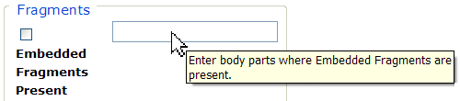
Figure 45 – Tool Tip for Text Box

Checkbox
SAMPLE:
A checkbox “toggles” (changes) between a YES / NO, ON / OFF setting. It is typically a square box which can contain a check mark or an “X” ☒ and is usually accompanied by text. Clicking the box or tabbing to the field and pressing the spacebar toggles the checkbox setting. In some instances, checkboxes may be used to provide more than one choice; in such cases, more than one box can be selected. Sometimes, a pre-determined “default” entry will be made for you in a checkbox; you can change the default if needed.
Radio Button
SAMPLE:
A radio button, also known as an option button, is a small, hollow circle adjacent to text. Radio buttons usually appear in sets, with each button representing a single choice; normally, only one button in the set may be selected at any one time. Clicking on the radio button places a solid dot in the circle, selecting the option. Clicking a selected radio button de-selects it, removing the dot. As one radio button is selected, others within the category switch off. For example, Male or Female may be offered as choices through two radio buttons, but you can only select one of the choices.
Command Buttons
SAMPLES | A command button initiates an action. It is a rectangular “3-dimensional” shape with a label that specifies what action will be performed when the button is clicked. Common examples are shown at left. Command buttons that end with three dots indicate that selecting the command may evoke a subsidiary window.  In the text of this document, command button names appear inside square brackets. Examples: [Search], [Save].
 | The [Cancel] command allows you to cancel the action about to be taken, or to discard changes made on a form. For example, when closing an application, you may be prompted to validate the action to close. If you click the [Cancel] button, the application will not close and you will resume from the point at which the close action was initiated. Or, on a data screen, you may use the [Cancel] button to discard any changes you may have made to the data and close the tab.
 | The [Select] command is used to select records for editing.
 | The [Search] command is used to find one or more records. When at least one character is typed in a lookup dialog box, clicking the [Search] button will bring up matching entries. In many cases, leaving the lookup box blank will find all such records. Enter the search string and click [Search]. Searches are case-insensitive and use “contains” logic.
 | The [OK] command is used to accept a default choice, or to agree with performing an action.
Drop-down List
SAMPLE 1:
SAMPLE 2: | 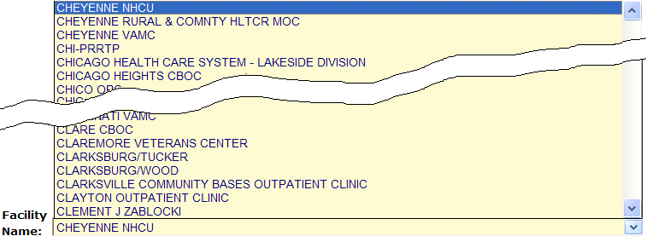
A drop-down list (sometimes called a “pull-down” list) is displayed as a box with an arrow button on the right side (SAMPLE 1). Such a list allows you to select one item from the list. The current choice (or a prompt) is visible in a small rectangle; when you click on the arrow, a list of items is revealed (SAMPLE 2). Click on one of the entries to make it your choice; the list disappears.

